Business Plan

ListenSmart.com, LLC



Prepared on:

March 29, 2000

Prepared by:

Sean P. Fenlon
President & CEO

TABLE OF CONTENTS
TABLE OF CONTENTS 2
TABLE OF FIGURES 5
EXECUTIVE SUMMARY 6
Introduction 6
“The Elevator Pitch” 6
The Market 6
The Issues & The Business Models 6
Building a Better “Mousetrap” 7
Artist & Repertoire Promotion 7
ListenSmart.com 8
SyncSmart.com 8
SmartAandR.com 8
Management 8
Sean P. Fenlon, President & CEO 8
Peter Lubin, VP of A&R 8
Hyun Lee, CTO 9
David Seidl, VP Strategic Development 9
Board of Directors 9
Corporate Infrastructure & Capitalization 9
BUILDING A BETTER “MOUSETRAP” 10
Finding Enjoyable Music 10
What & Where 10
What Do You Like? 12
What Do Other People Like? 12
Charts & Ranking 15
Functionality 17
Page Customization 17
Drop-down Menu Bar Navigation 19
Streaming 20
Downloads 21
Song Reviews 21
Song Ratings 21
Community 21
Free Member User Pages 21
Bulletin Boards 23
Chat Rooms 25
ICQ 26
Learn about music… 27
Artist collaboration 29
BUILDING A BETTER BUSINESS MODEL 30
Advertising Sales 30
Affiliate Link Advertising 31
CD Sales 31
SmartLabel CDs 31
SmartCompliation CDs 31
Consignment CD Sales 32
Artist Merchandise Sales 32
Music Publishing 32
Relationship with Independent Artists 32
Exposure & Promotion 33
Immediate Revenues 35
Future Revenues 36
ARTIST & REPERTOIRE PROMOTION 37
ListenSmart.com 37
SyncSmart.com 37
SmartAandR.com 38
Projections & Assumptions 40
Projections Summary At-a-Glance 40
Site Traffic 41
Site Visitors 41
Artist Enrollment 41
Publishing Revenue 43
Key Assumptions 43
Methodology 44
Pro Rata 52
Synchronization 54
Advertising Revenue 54
Banner Advertising Revenue 54
Rich Media Advertising 55
Newsletter Sponsorships 56
Sale of Email Addresses to Opt-In Affiliates 58
CD & Merchandise Sales + Affiliate Link Commissions 59
Affiliate Link Commissions 59
CD Sales 60
Artist Merchandise Sales 60
Two Year Revenue Totals 61
Marketing 62
Acquisition Costs 62
Affiliate Marketing 63
Misc. Forecast Notes 65
Potential Increases to Revenue Projections 65
Number of MP3.com artists signed 66
MANAGEMENT 68
Sean P. Fenlon, President & CEO 68
Peter Lubin, VP of A&R 68
Hyun Lee, CTO 69
David Seidl, VP Strategic Development/Legal Counsel 69
BOARD OF DIRECTORS 69
Jim Griffin 69
Ted Cohen 70
Paul Bandrowski 70
CAPITALIZATION 71
Current Status & General Need for Capital 71
Market Position & Opportunity 71
Exit Strategy& Use of Startup Capital 71
APPENDIX 73
Competition Analysis 73
Music Publishing 76
Intro 76
Performing Rights Payments 76
CD, Tape, & Record Sales 77
Controlled Composition Clauses 77
Television 78
Motion Pictures 79
Home Video 80
Commercials 80
Broadway Musicals 81
Recording Artists Royalties 81
Foreign Country Royalties 82
Conclusion 82
Single Song Royalties Example 83
Advertising Royalties Formula 84
Reversion Clause Flowchart 85
Artist Meta-Data Collected by ListenSmart 86
Song Meta-Data Collected by ListenSmart 88

TABLE OF FIGURES
Figure 1: Sample Genre Home Page (w/Description) 11
Figure 2: Sample Artist Home Page 14
Figure 3: Sample Popularity Chart Page for Alternative 15
Figure 4: Home Page with Side Column Modules Collapsed 18
Figure 5: Home Page with Side Column Modules Open 19
Figure 6: Example of Drop-down Style Menu Bar 20
Figure 7: Sample Free Member User Page 22
Figure 8: Example of User Page Customization Functions 23
Figure 9: Sample Bulletin Board 24
Figure 10: Different Bulletin Board "Forums" 25
Figure 11: Sample Avatar Chat Room 26
Figure 12: ICQ Screenshot 27
Figure 13: Sample Artist Signup Interview Procedures 34
Figure 14: ListenSmart Business Model Flow Chart 39
Figure 15: Sample 468x60 Banner Ad 54
Figure 16: Sample 100x100 Promo Banner Ad 54
Figure 17: Download/Stream Request Dialog Box Screenshot 57
Figure 18: NMPA Survey of Music Publishing Revenue Growth 65
Figure 19: Advertising Royalties Formula 84
Figure 20: Reversion Clause Flowchart 85

EXECUTIVE SUMMARY

Introduction

“The Elevator Pitch”
ListenSmart.com is an Internet portal for independent musicians with a business model whereby the artists will share 50% of the revenues generated by the site based on the popularity of their music. In exchange for this “revenue-sharing” status, independent artists establish ListenSmart.com as their contractual music publisher on a song-by-song basis, thus creating potentially explosive revenue growth through music publishing royalties. For each “revenue sharing” song or composition, the artist will sign a standard single-song publishing contract that will entitle ListenSmart.com to 50% of the music publishing royalties generated by the song for the life of the contract, including broadcast royalties (i.e. radio), synchronization royalties (i.e. TV, Film, etc.), mechanical royalties (the selling of CD's, sheet music, etc.), grand rights (theater), and foreign royalties. Another fundamental key to the plan is to create sophisticated filtration technologies – much more sophisticated than had ever been introduced before – that would allow listeners a much greater chance to find new music they are likely to enjoy, quickly and easily. Finally, the revenue potential from publishing royalties would be maximized with two “sister” business-to-business Internet web sites, SyncSmart.com (for synchronization music licensing, i.e. movie & TV producers) and SmartAandR.com (for record labels, A&R representatives, and record producers), as well as a conventional offline artist promotion/music publishing staff.

The Market
The music publishing industry is a $6+ billion per year market and has shown steady and consistent growth. The key to music publishing royalties is quality content. ListenSmart.com’s primary focus is to aggregate the highest quality content of independent musicians – it’s core constituency.

There are an estimated 67+ million amateur musicians in the U.S. alone, and more than 1 million with recorded content (NAMM 1998). Furthermore, there are only an estimated 100,000 artists who have made their content available on the Internet for distribution. Thus, a major goal is to capture a significant portion of the offline artist community as they are entering into the space of online digital music – a space we believe that all artists will occupy at some point in the near future.

The Issues & The Business Models
Through the use of digital compression schemes (such as MP3 technology) and the Internet, all musicians now are able to have their music listened to by anyone in the world with a computer and Internet access without any of the filters or barriers represented by the traditional recording industry. The keys for the artists, however, is finding the audience that will appreciate and enjoy their work, developing relationships with those listeners, then maximizing the monetization of their relationships. Please note, however, that these keys are functions that many artists are either incapable of or uninterested in performing themselves – or at least without help.

Within the changing online music landscape, two basic business models have taken shape, neither of which has been particularly favorable to the independent artist in general. The first model is an e-commerce play, i.e. sell “stuff” online. “Stuff” could take the form of physically produced CD’s (i.e. CDnow.com) or music in downloadable form (i.e. Emusic.com). For artists without the immediate name recognition and immediate appeal to consumers, this is an ineffective model.

The other model is an advertising-only play such as MP3.com. Not only does this model typically eliminate the content-creating/traffic-driving artists from the primary revenue stream, but it also a model that continues to be criticized as one to build a viable, robust business. The genius of the ListenSmart.com business model, however, is its ability to combine several online and offline profit centers, while still allowing the cost to consumers to remain at zero, and while still appropriately sharing the primary revenue streams with artist 50/50.

The five profit centers of the ListenSmart.com business model are:
- Advertising Sales
- CD Sales (through automated production and consignment sales)
- Artist Merchandise Sales (through outsourced/automated production and consignment sales)
- Affiliate Link Advertising Commissions
- Music Publishing Royalties – Clearly the “crown jewel” of the business model

Building a Better “Mousetrap”
In addition to a much more robust and viable business model than those that have been introduced thus far, ListenSmart.com expects to become the premiere destination for online music through its sophisticated functionality and user-friendly design. Moreover, a strong emphasis will be placed on creating a sense of “community” amongst the artists and the listeners. Site features will include:
- Fully customizable home page for artists and listeners
- Sophisticated music “filtration” technologies
- Simple navigation techniques that will allow even first time users to find music that they are likely to enjoy quickly and easily

Artist & Repertoire Promotion
The key to maximizing the business relationship with the independent artists is to maximize their royalty-earning potential using a three-pronged attack – affectionately referred to as the “SmartSuite” – with two business-to-business plays supporting the main business to consumer play.

ListenSmart.com
ListenSmart.com is clearly a business-to-consumer (or artist-to-consumer) play. Thus, ListenSmart.com will become a “clearinghouse” for market tested artists and repertoire that will then be promoted in the “sister” business-to-business plays, SyncSmart.com and SmartAandR.com.

SyncSmart.com
ListenSmart.com’s "Revenue Sharing" artists will have their music included in the SyncSmart.com database of music for movie, TV, film, or commercial synchronization material. This business-to-business service will be promoted to film and video producers, advertising agencies, and music supervisors worldwide as an efficient means to find appropriate synchronization material for their project based on their specific criteria and budget.

SmartAandR.com
The second sister business-to-business play will be directed toward record labels, A&R representatives, and record producers looking for new material or to sign new talent. Visitors will be able to utilize the clearinghouse function of ListenSmart.com by creating their own “success-factor index” based on the popularity charts found on ListenSmart.com. By applying customizable algorithms to their search criteria, a perfect match can be found. Results will also display pertinent business information such as management, legal representation, touring experience/ability, etc. along with direct contact information.

Management
The management team of ListenSmart.com, LLC brings together a wealth of experience and accomplishments in the business, music, Internet, e-commerce, finance, and high technology industries.

Sean P. Fenlon, President & CEO
Sean P. Fenlon is a lifelong hi-tech musician who has studied with the finest teachers at the finest institutions including The Peabody Institute of Music where he earned his Doctorate in Musical Arts. Mr. Fenlon has had experience with the Internet in the digital music arena from its inception. In the business world, Mr. Fenlon spent two years as the Director of Business Operations of Investors Mortgage Corporation (Columbia, MD) where he managed over forty employees and helped to increase the gross revenues from $2,000,000 to $5,000,000 per annum. Mr. Fenlon is the creative visionary and the driving force behind the ListenSmart.com model and function.

Peter Lubin, VP of A&R
Mr. Lubin is a veteran Artist & Repertoire executive in the recording industry, where he served as Senior Vice-President of A&R for Mercury, RCA, and Elektra until 1997. He was responsible for the signing of many established and emerging artists including The Moody Blues, Peter Gabriel, Michelle Shocked, Robert Cray, The Pixies, The Breeders, They Might Be Giants, Phish, and The Refreshments. Prior to joining ListenSmart.com, Mr. Lubin provided services as an A&R consultant to various record labels, on-line companies, and media start-ups. He also serves on the Board of Directors of Digital Media On Demand, Inc. (DMOD).

Hyun Lee, CTO
Hyun Lee is the founder of Netronics Inc., a company specializing in web application development and consulting. Having earned a degree in Electrical Engineering at Georgia Institute of Technology (Georgia Tech), Hyun Lee has years of experience as an Internet application developer and web business solution provider including Bell Atlantic intranet applications, Korean Department of Defense intranet solutions, and Koreatimes.com. Mr. Lee also has years of experience and knowledge in system architecture, programming, and network design on a variety of platforms.

David Seidl, VP Strategic Development
David Seidl has been a practicing corporate law attorney and a partner in the esteemed Baltimore law firm Miles & Stockbridge since 1983. In addition to his law practice, Mr. Seidl has launched several successful business endeavors including a chain of "Mamma Ilardo’s" pizzeria restaurants and a thriving Internet investment group. Mr. Seidl is also a specialist in representation of privately-held startup businesses.

Board of Directors
At this time, we have secured verbal board seat agreements from three of the most significant players in online/new-media space, Jim Griffin (President & CEO of Cherry Lane Digital/OneHouse), Ted Cohen (VP of New Media for EMI), and Paul Bandrowski (Vice-Chairman and former CEO of Reciprocal).

Corporate Infrastructure & Capitalization
ListenSmart.com, LLC was incorporated on 8/23/99 as a Limited Liability Corporation. Our corporate headquarters is “Class A” office space in Columbia, MD (approx. ½ way between Baltimore & Washington D.C.).

The ListenSmart.com full-time staff currently numbers seven, with five members specifically assigned to the technical/development team. We are approximate eight months into the development of a prototype web site. We originally secured a $5 million pre-money valuation via $500,000 in angel-round investment from eight private equity-based investors, and an additional $250,000 in seed capital to support the “soft launch” of our beta site. We will be closing a second-round equity investment (first institutional round) of $1,000,000 within the next 6-8 weeks from the PsiCon Global Accelerator Fund (a joint early-stage fund of Psilos Ventures and Constellation Ventures). The pre-money valuation will be $6 million. We are also seeking additional beneficial working relationships with several key strategic partners.

BUILDING A BETTER “MOUSETRAP”
Clearly, the first generation of MP3 or other independent music sites have already made their debut. Thus, most fans of online music have become quite familiar with the basic functions of MP3.com and other independent music sites that offer free and legal downloadable MP3 files. However, ListenSmart.com has attempted to synthesize all of the best elements from all of these sites, effective elements from non-music sites (i.e. amazon.com), and also functions that have never been implemented before. Many of the new implementations were created from scratch, however, months of monitoring the MP3.com and AMP3.com Artist-Only Bulletin Boards, where great ideas are posted on an almost daily basis, derived most them. Finally, ListenSmart.com will implement a radically new business model with explosive potential – in conjunction with our “better mousetrap” – that could forever change the music business, as we know it.

Finding Enjoyable Music
Perhaps the greatest complaint of the users of independent music sites is the amount of time and effort it takes to locate music that they are likely to enjoy. This is a genuine concern when dealing with “unfiltered” independent music of varying levels of performance and production. A potential criticism of the unfiltered approach is that ListenSmart.com is certain to attract music of poor quality. It is our position, however, that someone has to make that decision and we feel as though the end-user (listener/consumer) will make a better choice than that of a major recording industry professional or us.

MP3.com, along with other independent music/MP3 sites, often arbitrarily “feature” or “spotlight” bands or artists on the home page or in a prominent location based on the tastes of the site administrators. We believe this practice is outdated and misguided. ListenSmart.com will take a different approach by trying leverage the collective opinions of an entire community to determine prominence. Firstly, ListenSmart.com has established several sophisticated approaches to allow listeners to identify new music that they are the most likely to enjoy immediately, based on their current preferences. Secondly, we feel that ListenSmart.com methods of popularity charts will create a true market economy for music and that "musical Darwinism" will be the music industry's model in the next millennium.

What & Where
Typically, music fans are quite familiar with identifying music by style and also by geography. Therefore, one approach to lead listeners to music that they will enjoy is categorizing it by Genre and also by Region.

Genres, Genres, & More Genres
Most listeners can quickly identify their favorite style or genre. Thus, ListenSmart.com has created one the most complete and sophisticated “Genre Trees” ever assembled. At the highest level are twelve main genres. Each main genre can contain many sub-genres, which can contain sub-sub-genres and so on. All tallied, there are over 450 genre categories. However, each genre will have a brief essay or description to indicate its distinction, thus neither the artist nor the listeners will ever wonder – for example – “What exactly is ‘Trance’”?

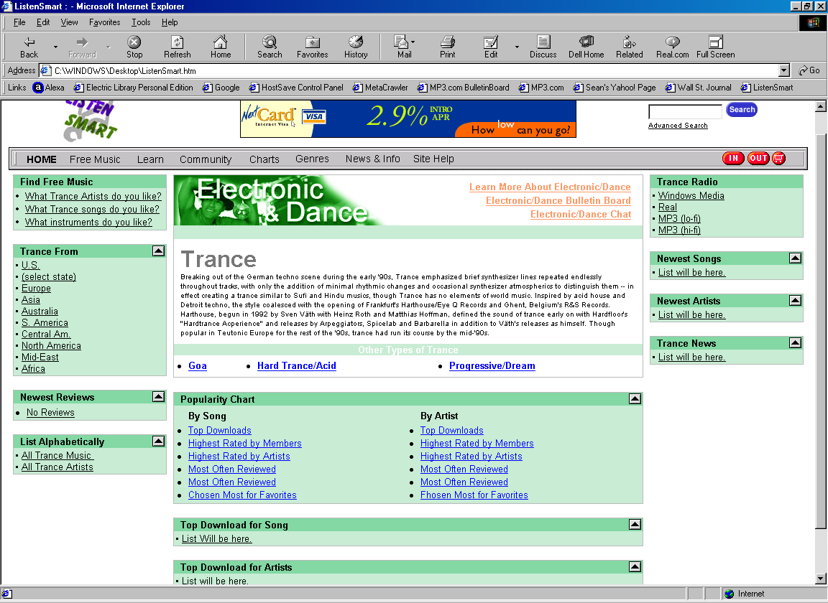
Figure 1: Sample Genre Home Page (w/Description)

Artists will be allowed to associate up to three genres for each of their songs, although one must be identified as the Primary Genre. Also, artists will be encouraged to submit new genre categories, however, for the request to be approved, they must also submit a description and essay to define its significance (subject to editing and verification, of course). In today’s age of crosscurrent influences, further fragmentation of the genre structure is inevitable and should be embraced as a tool for finding music.

Regions & Local Music
Many listeners will want to find music based on their residence or based on a certain “sound” identifiable by certain geography. These searches can also be cross-tabulated to find music that is, for instance, “Trance” in Lawrence, Kansas.

What Do You Like?
Listeners are all experts to the extent that they know what they like. To that end, ListenSmart.com will try to leverage their own “expertise” to lead them to new music that they are likely to enjoy.

“What Artists Do You Like?”
Most listeners can quickly identify their favorite – popular – artists in an instant. Thus, ListenSmart.com will try to connect listeners to new artists based on their current favorites. As a new artist signs up, they are asked what “popular or famous” bands or artists their fans are likely to listen to. The artist may select up to three “popular or famous” artists from a list provided. Also, the list may be appended by the user with an entry that will the become part of the “master” list.

On each main page, a function will be displayed the prominent upper left hand column asking, “What bands/artists do you like?” By selecting this function, the listener will be displayed a list of “popular or famous” artists such as The Beatles. By selecting The Beatles, the listener will then see a list of ListenSmart.com artists – sorted by popularity – who have indicated that their fans are likely to also like The Beatles. Thus, the listener is introduced to new artists based on their current preferences.

“What Songs Do You Like?”
Most listeners can also quickly identify their favorite songs in an instant. Thus, ListenSmart.com will also try to connect listeners to new songs based on their current favorites. As an artist signs up a new song, they are asked – fans of what “popular or famous” songs would also enjoy this new song. The artist may select up to three “popular or famous” songs from a list provided. Also, the list may be appended by the user with an entry that will the become part of the “master” list.

On each main page, a function will be displayed the prominent upper left hand column asking, “What songs do you like?” By selecting this function, the listener will be displayed a list of “popular or famous” songs such as “Twist & Shout.” By selecting “Twist & Shout,” the listener will then see a list of ListenSmart.com songs – sorted by popularity – that have been associated with “Twist & Shout.” Thus, the listener is introduced to new songs based on their current preferences.

What Do Other People Like?
Harnessing the power of the Internet and a virtual community can also be an effective way to light a path for listeners to find new music that they are likely to enjoy.

“People who enjoyed this artist also enjoy these artists…”
Once a listener finds a new artist in which they enjoy, the goal is to light a path to more artists that are also likely to enjoy. Thus, by taking a page from Amazon.com, ListenSmart.com will track download patterns of each individual to calculate the next most downloaded artist based on the aggregate of the individuals who have downloaded the current artist. Thus, the goal is to allow listeners of similar tastes to share experiences using a technology called “collaborative filtering.”

“People who enjoy this song also enjoy these songs…”
Once a listener finds a new song in which they enjoy, the goal is to light a path to more music that are also likely to enjoy. Thus ListenSmart.com will track download patterns of each individual song to calculate the next most downloaded songs based on the aggregate of the individuals who have downloaded the current songs. Thus, the goal is to allow listeners of similar songs tastes to share experiences using a technology called “collaborative filtering.”.

Figure 2: Sample Artist Home Page

Comparing Favorites
Next to each song, each artist, and each genre will be a button function labeled “Add this to my list of favorites.” Not only will this allow the member user to dynamically include that item in their own member page, but it will also allow them to compare their favorites to other member’s favorites. On each member’s page, at the bottom of each “Favorites” list, will be a button function that will activate a query to find and display the closest matching “Favorites” from other members. If two members share eight out of ten favorites, they should feel encouraged to listen to the two that do not match. They are very likely to enjoy what they find.

Charts & Ranking
Perhaps the most familiar way people are presented with new music is through popularity charts. Thus, ListenSmart.com will amplify the choices typically found in traditional charting methods.

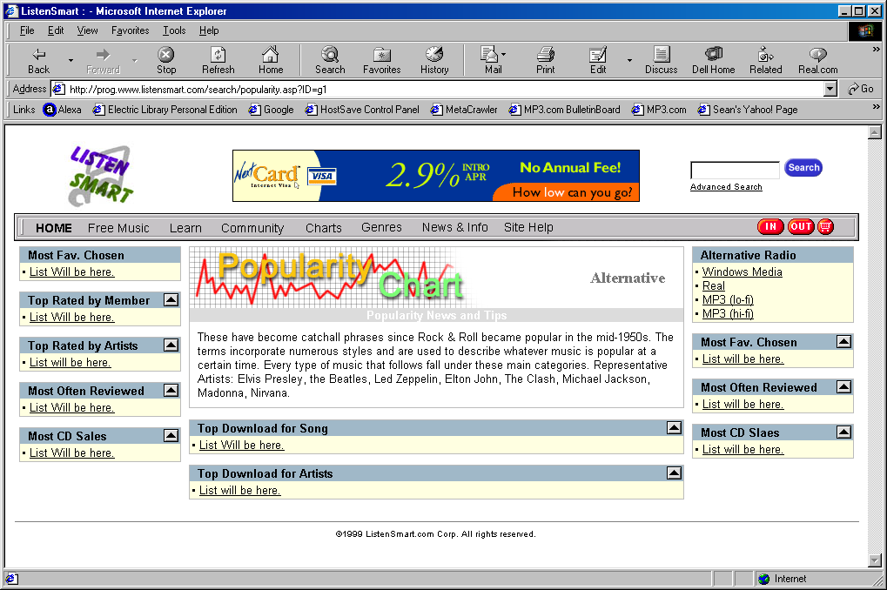
Figure 3: Sample Popularity Chart Page for Alternative

Find Artists by Popularity
Artist popularity will be based by comparing the aggregate of the artist’s songs to the aggregate of all the other artist’s songs.

Most Downloads
This chart will display which artists have had the most songs or compositions downloaded from ListenSmart.com. This rank takes into account the total of all downloads from all of the songs posted by the artist. The chart defaults to results based on the previous day only, however, you can adjust the results by using the drop down box to view results based on the previous week, the previous month, and the previous year.

Most Visits to Home Page
This chart will display which artists have had the most visits to their ListenSmart.com homepage. The chart defaults to results based on the previous day only, however, you can adjust the results by using the drop down box to view results based on the previous week, the previous month, and the previous year.

Most CD Sales
This chart will display which artists have sold the highest dollar amount in Compact Disc sales, including their own discs and compilation CDs. Artists who are included on compilation CDs are credited their appropriate percentage of the sale price. The chart defaults to results based on the previous week only, however, you can adjust the results by using the drop down box to view results based on the previous month, and the previous year, and overall.

Most Often Chosen for “Favorites”
This chart will display which artists have been selected the most by ListenSmart.com members to be listed on the “Favorite Artists” section of their free homepage.

Find Songs by Popularity
Song popularity is determined on a unit-to-unit basis.

Most Downloads
This chart will display which songs or compositions have been downloaded the most often from ListenSmart.com. The chart defaults to results based on the previous day only, however, you can adjust the results by using the drop down box to view results based on the previous week, the previous month, and the previous year. This chart is useful to determine what songs ListenSmart.com listeners would like to keep or hear again.

Highest Rated
This chart will display which songs or compositions have been rated the highest overall by artists or by members. Both ListenSmart.com members and artists can review and rate the songs they hear on a scale from 1-10. Only songs that have been rated by at least five different artists or members are included in the listing. This chart is useful to determine what songs ListenSmart.com artists and members consider to be the highest quality. Also, to offer a more detailed perspective, the chart is further divided into two categories; “Highest Rated by Artists” and “Highest Rated by Members.”

Most Often Reviewed
This chart will display which songs or compositions have had the most reviews written by ListenSmart.com artists or members. The chart defaults to results based on the previous week only, however, you can adjust the results by using the drop down box to view results based on the previous month, and the previous year, and overall. This chart is useful to determine what songs are really creating a “buzz.” The calculation will be based on the total row count in the SONG_REVIEW fields.

Most Single Song Sales
This chart will display which ListenSmart.com songs have sold the highest dollar amount in compilation Compact Disc sales, including their own discs and compilation CDs. Artists who are included on compilation CDs are credit their appropriate percentage of the sale price. The chart defaults to results based on the previous week only, however, you can adjust the results by using the drop down box to view results based on the previous month, and the previous year, and overall. This chart is useful to determine the ListenSmart.com artists that listeners will pay money to hear.

Most Often Chosen for “Favorites”
This chart will display which songs have been selected the most by ListenSmart.com members to be listed on the “My Favorite Songs” section of their free homepage.

Functionality
ListenSmart.com will feature some of the most sophisticated functionality found on any music-related web site.

Page Customization
Each and every page at ListenSmart.com has been developed using the same “collapsible module” technology. This technology – for which Excite recently won the Comdex award for “Web Application of the Year” – allows a user to open and close modular “boxes” based on their preference of page functionality. The process is familiar to any computer user accustomed to using the minimize/maximize functions of most graphical operating systems. Moreover, when a visitor makes a change to a page, a cookie stores their change and will restore their same layout on future visits. Below are two screen shots of the preliminary ListenSmart.com home page; one with all (side column) modules collapsed, one with all modules expanded. This allows users to set pages throughout the entire site to their own comfort level without any additional confusion.

Figure 4: Home Page with Side Column Modules Collapsed

Figure 5: Home Page with Side Column Modules Open

Drop-down Menu Bar Navigation
For a site as large in scope as ListenSmart.com, navigation becomes a fundamental concern. We will address this concern – in part – by implementing a sophisticated – yet familiar – drop-down menu bar to allow users to navigate to anywhere, from anywhere, using an interface they are accustomed to in just about any PC application. In fact, our graphics were designed to emulate the drop down menus of standard Windows applications the encourage comfort with its function.

Below is a screenshot to demonstrate the drop-down menu that appears when a user clicks on “Genres.” Notice the similarity to standard menu bars and the blue arrow that tracks the users mouse position within the list (next to “World/Folk”)

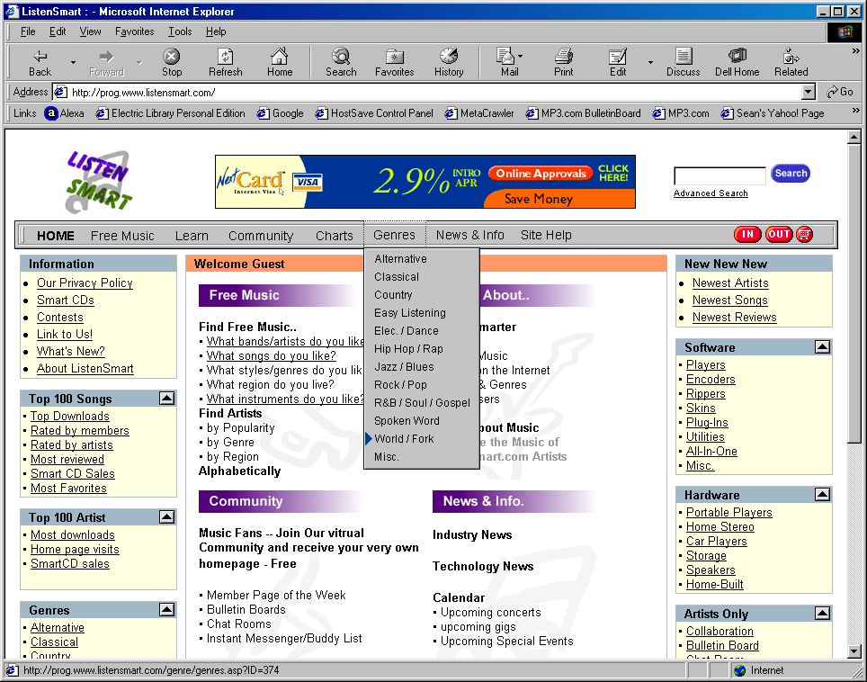
Figure 6: Example of Drop-down Style Menu Bar

This menu bar functionality is implemented using JavaScript and has been tested, re-tested, and debugged. Further, users whose browsers do not support Java or have disabled Java will simply be re-directed – on click – to a static page that contains the same choices as the selections with the drop-down box.

Streaming
Users of the site will have the ability to listen to every individual song throughout the site – as well as every list of songs – as a real-time audio stream using one of the four options:

- Windows Media
- RealAudio
- MP3 (128Kbs Stereo – “Hi Fi”)
- MP3 (24Kbs Mono – “Lo Fi”)

Additionally, listeners will be able to activate play lists to listen to all of an artist’s songs or all of the songs listed on a popularity chart (i.e. the top 100 Jazz Fusion downloads).

Downloads
All songs on the site will be available for download – from the respective artists’ homepage only – in a native MP3 file format encoded at standard 128Kbs.

Song Reviews
Listeners will have the opportunity to post reviews and comments on all songs. However, due to the cantankerous nature of some reviewers, this has been a controversial function amongst the artist community. Thus, ListenSmart.com will let the artist determine whether or not reviews will be allowed for their songs when signing up.

Song Ratings
All songs will be available for a rating from 1 through 10. The artist cannot de-activate this function since it will be an important popularity chart function. However, to rate a song in any specific genre, the user must have selected that particular genre as on of their “favorite genres” on their member page. This will lend more credibility to the rating index.

Further, functionally speaking, only songs with at least five reviews will appear on the charts and the single highest and the single lowest review will not be included in the calculation.

Community
"Virtual communities" are currently one of the Internet's hottest trends. The vision behind ListenSmart.com is to become a robust "virtual community" on the Internet for consumers who want to listen and learn from the plethora of music that traditional music labels and retailers do not usually offer. This will allow an avenue for independent artists to distribute their music and build a fan base. This type of environment can add value and vigor to the creative music community at large. It can showcase artists and light a path for the consumer at the same time. It also creates a connection among people who can easily identify and navigate among musical choices and genres, creating shared listening experiences.

Free Member User Pages
In addition to artists being able to create their own homepages, registered members will also be given the opportunity to create a home page using a “EZ Builder” interface. Members can upload pictures, insert text and messages and also customize the colors, look, and feel of the page without any design or HTML experience. Once a member has created a page, it will become the center of functionality for the user. Also, members can encourage others users to visit their page using an “express” URL such as www.listensmart.com/members/user-name-here.

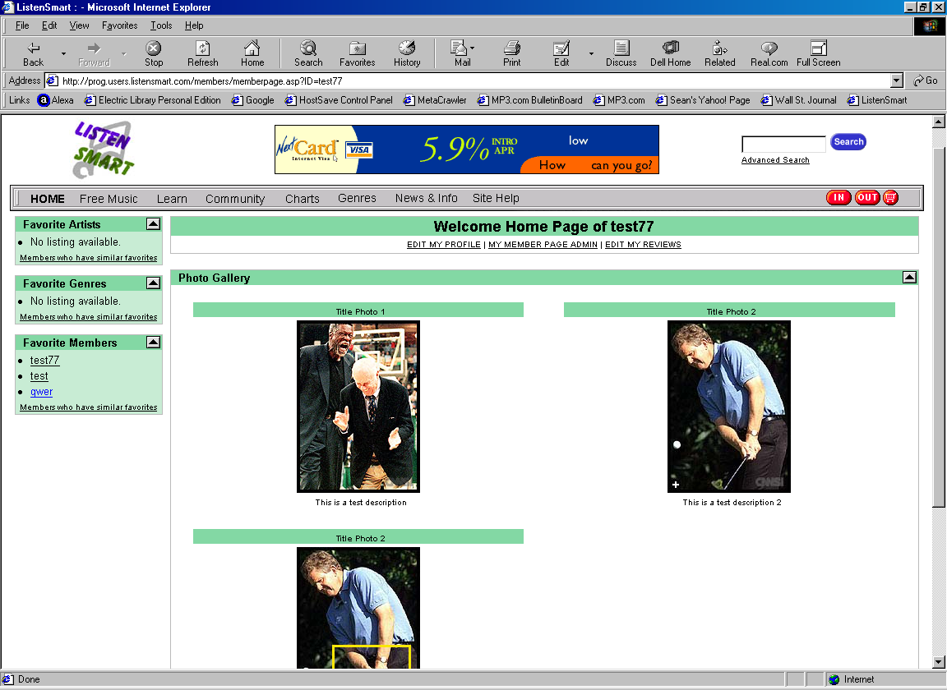
Figure 7: Sample Free Member User Page

Making changes and administering member pages will be very simple using a graphical interface that will allow users to preview their changes or additions in real-time using simple dialog boxes, drop down selectors, and Windows-like icons in the top right corner of modules. Notice below the drop-down box that allows a user to modify their color scheme.

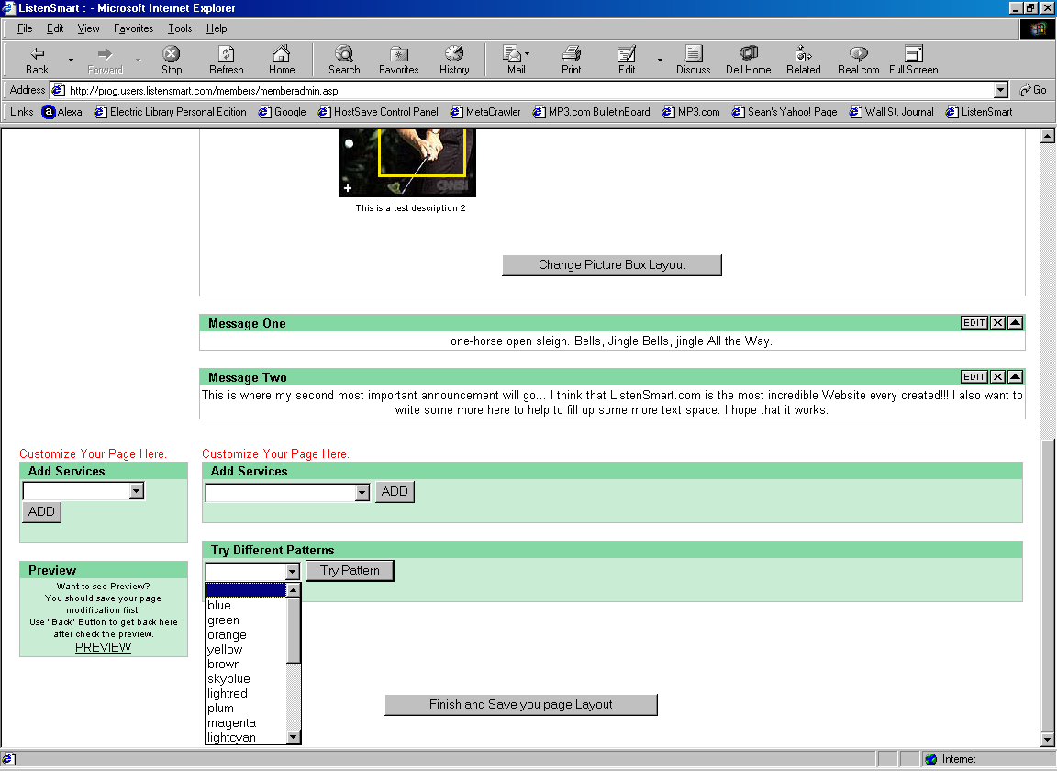
Figure 8: Example of User Page Customization Functions

Featured Member Page of the Week
Members that are the most creative with their page design and customization will be awarded a prize at the end of every week. The prize value will range from $50-100.

Most Visited Member Pages
Member page traffic will also be tracked and displayed on a “popularity chart” to encourage interaction and traffic among members.

Bulletin Boards
Creating interactive forums that let visitors talk to each other and to the artists will give visitors a reason to return. For bulletin board functionality, ListenSmart.com will use the package offered by Ultimate Bulletin Board (www.ultimatebb.com) to provide functionality. This robust package has become a standard on such sites as MP3.com and AMP3.com.

Chat Rooms
ListenSmart.com will also offer state-of-the-art multimedia Avatar chat rooms with compelling backgrounds using The Palace Chat server (www.thepalace.com).

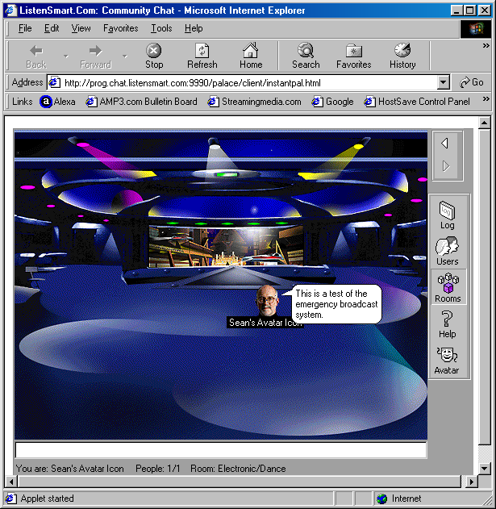
Figure 9: Sample Avatar Chat Room

ICQ
The “underground” rise of MP3 popularity is virtually parallel to the “underground” popularity of instant relay chat. Moreover, we feel as though additional communication will enhance the overall sense of virtual community to create interaction among artists and listeners. Thus, ListenSmart.com will host and prominently encourage the use of ICQ from with the community sections of the site.

Learn about music…
To create the perfect music appreciation type of environment for music listeners, ListenSmart.com will offer a wealth of additional information for those visitors who feel compelled to learn more about the world of music. Articles (approx. 500-1000 words in length) and pictures will be prepared by doctorate students of The Peabody Institute on the following topics:
- About Music
    - Melody
    - Harmony
    - Rhythm
    - Sound/Timbre
        - Orchestration/Instrumentation
    - Texture
        - Monophonic
        - Homophonic
        - Polyphonic
    - Form
        - Song Form
        - 12-Bar Blues
        - Sonata Forms
        - Rondo Forms
    - Counterpoint

- Digital Music
    - Brief History
    - Brief Overview
    - Advantages & Disadvantages
    - DAC & ADC
    - Sampling/Bit Count
    - Digital Music Formats
        - CDs
        - DAT
        - Mini-Disc
        - MDM
        - Computer Based
    - MIDI

- Computer Music
    - Hardware
    - Software

- Music on the Internet
    - Streaming Audio & Internet Radio
        - Real
        - Windows Media
        - SHOUTcast!
        - Flash
        - MP3 streams
    - Downloadable Music Formats
        - MP3
        - .wav Files
        - QuickTime
        - Liquid Audio
        - SDMI/Aris
        - a2b
        - VQF

- Music History
    - Ancient Music
        - Brief History & Overview
    - Middle Ages
        - Brief History & Overview
    - Rennaissance
        - Brief History & Overview
    - Baroque
        - Brief History & Overview
        - Composers
            - Corelli
            - Vivaldi
            - J.S. Bach
    - Classical
        - Brief History & Overview
        - Composers
            - Haydn
            - Mozart
            - Beethoven
    - Romantic
        - Brief History & Overview
        - Composers
            - Brahms
            - Wagner
            - Strauss
            - Mahler
            - Tchaikovsky
    - 20th Century
        - Brief History & Overview
        - Composers
            - Debussy
            - Stravinsky
            - Bartok
            - Gershwin
            - Copland
            - Schoenberg

- Instruments
    - Keyboard Instruments
        - Piano
        - Synthesizers
            - Additive Synthesizers
            - Subtractive Synthesizers
            - FM Synthesizers
            - Sample-playback synths & Samplers
            - Physical Modeling Synthesizers
        - Clavinet
        - Harpsichord
        - Accordion
        - Celeste
        - Organ
            - Hammond B3 Organ
    - Stringed Instruments
        - Bowed Instruments
            - Violin
            - Viola
            - Cello
            - Contrabass
        - Plucked/Strummed Instruments
            - Guitar
            - Electric
            - Acoustic
            - Banjo
            - Harp
            - Sitar
            - Bass
            - Lute
            - Ukulele
            - Mandolin
    - Wind Instruments
        - Woodwinds
            - Recorder
            - Flute
            - Alto Flute
            - Piccolo
            - Oboe
            - English Horn
            - Clarinet
            - Bass Clarinet
            - Bassoon
            - Contrabassoon
            - Saxophone - General
            - Soprano Sax
            - Alto Sax
            - Tenor Sax
            - Bari SAx
        - Brass
            - Trumpet
            - Fluglehorn
            - Piccolo Trumpet
            - Trombone
            - Bass Trombone
            - Valve Trombone
            - French Horn
            - Euphonium
            - Tuba
    - Percussion
        - Drum Set
        - Drum Percussion
        - Mallet Percussion
        - Aux. Percussion
    - Electronic
        - Theremen / DJ Turntables
        - EWI / EVI
    - Misc Instruments
        - Jaw Harp
        - Hammer Dulcimer
        - Bagpipes
        - Vocals as an instrument
        - Didgeridoo
        - Harmonica

Furthermore, instrument articles can tie directly to the musical content on the site. For example, a visitor reads an example on an exciting new instrument called the Flugelhorn. He can then activate a function that will search the entire song database of songs using a flugelhorn and display the results sorted by popularity.

Artist collaboration
As a means of encouraging a pro-artist community, part of ListenSmart.com will be devoted to artist collaboration. Artists from around the world be able the share musical ideas by using functionality similar to a bulletin board. Rather than posting text messages, however, partial or complete collaboration-ready music will be posted using various file formats including:
- MP3
- General MIDI
- Cakewalk .bun files
- Cubase Audio VST
- Logic Audio
- Studio Vision (Mac)
- Digital Performer (Mac)

File format sections will be further broken into main genre categories. The overall structure of the section will be similar to a bulletin board where an artist can post an original groove and others can “reply.” New “threads” can also branch off in different directions. The online/MP3 artist community has already begun these types of collaboration efforts in private. ListenSmart.com will be one the first of its kind to provide artists with an infrastructure to facilitate the online collaboration phenomenon.

BUILDING A BETTER BUSINESS MODEL
Two basic business models have taken shape in the online music arena, neither of which is particularly favorable to the independent artist in general. The first model is an e-commerce play, i.e. sell “stuff” online. “Stuff” could take the form of physically produced CD’s or music in downloadable form. For artists without the immediate name recognition and immediate appeal to consumers, this is an ineffective model. The other model is an advertising-only play such as MP3.com. Not only does this model typically eliminate the content-creating/traffic-driving artists from the primary revenue stream, but it also a model that continues to be criticized as one to build a viable, robust business. The genius of the ListenSmart.com business model is its ability to combine several online and offline profit centers, while still allowing the basic costs to consumers at zero, and still sharing the primary revenue streams with artist 50/50 based on their popularity.

Advertising Sales
All of the music hosted and promoted by ListenSmart.com will be offered as downloads for zero cost to the consumer. Despite many engaging and attractive features, the main attraction to the site will be the sheer entertainment value of the free music. Virtually all of the features and functions of the site will directed towards creating a greater sense of involvement between the listener and the music. Also, there will be compelling reasons for listeners to return do to the constant addition of content via the artist’s new music and the contributions from the "virtual community."

With proper marketing, this approach of free content combined with a "virtual community" is proven to generate massive amount of traffic to the site. We feel as though our goal of 1 million unique visitors per day is quite obtainable. Along with this high level of daily traffic comes the ability to generate significant advertising revenue. Our advertising rates could also be particularly profitable because of the demographics we expect to serve, in addition to the personalization that will be possible by matching advertisers to community member's profiles through data mining.

Moreover, ListenSmart.com will be able to offer advertisers a viable alternative to the standard banner ad. Whenever a user of the site activates any streaming song play list (i.e. Top 100 Jazz Fusion Songs), we will offer the advertisers an opportunity utilize multimedia streaming technology to display a 10-second rich media advertising clip (using audio, video, flash, etc.) within the RealPlayer or Windows Media player at the beginning of the playback. Due to the targeted nature of the audience and the impact of rich media, this technique will maximize advertising revenues.

Affiliate Link Advertising
Part of our "virtual community" approach will be to offer various review and/or information on products relating to music, CDs, books or audio equipment. These reviews and/or information can come from staff-authored features or content provided by artists or members. Most of these products will also be for sale on the Internet, and our structure will always allow a user to link to where a product is available. Should the user purchase the item after linking from our site, the potential for commission or revenue sharing is created. This concept has been named "Affiliate Link Advertising." Affiliate marketing programs are one of the hottest marketing tools on the Web today. In an affiliate arrangement, advertisers create relationships with websites that agree to place links on their pages to be paid by commissions on product sales.

CD Sales
Another revenue stream will be created through the sales of “produced on demand” CDs. ListenSmart.com will implement the turn-key solution for CD production offered by Rimage (www.rimage.com). Although the music featured on the site is free in its digital state, users who wish to own the music in a physical manner will be offered CDs. The price of CDs can actually be perceived and/or presented as a "service" charge for recording the free music to a blank CD and shipping it directly to the customer.

SmartLabel CDs
SmartLabel CDs are similar to MP3.com’s DAM CD program where artists can create their own CD using a web-based interface. However, artists will be given much more flexibility in terms of graphical content, text content, and a much less obtrusive logo. Artists may also set their own unit prices from $5.99 - $18.99 and receive a 50% commission. Moreover, shrink-wrapping and bulk discounts will be offered to musicians looking to stockpile saleable units for live events in addition to local CD retailers.

SmartCompliation CDs
"SmartCompilation CDs" will be branded as such because of its extraordinary value and the ultimate control the customer will have in its creation.

What makes this approach unique, however, is the opportunity it gives to a listener to create his or her own compilation/greatest hits CD, up to 650MB of data. Customers will have the choice to add songs or compositions that they enjoy to their SmartCompilation CD by using the "Shopping Cart" system that has become so familiar in E-commerce. Customers can even add to their shopping cart over multiple online sessions and the "contents" of their shopping cart will be retained. Additionally, customers will not only have a choice of all the music available on the site, but they will also have their choice of format, MP3, CD digital audio (red book standard), or both. Should a customer select CD digital audio only, he could select up to 74 minutes of music. Should a customer select MP3 file formats only, he could select approximately 130 songs (using 5MB as an average file size).

The production of the CDs will be kept to a bare minimum of time and resources through automation. Carefully programmed procedures will automatically record all of the customer's requests onto a blank CD and a generic CD cover with basic track information will be printed. The package will then be shrink-wrapped and shipped within 24 hours to the customer and his credit card will be billed.

The ability to maximize and customize each CD by song, composition, and file format creates a tremendous value for the customer. Furthermore, through automation, the unit cost to the company remains the same regardless of the amount or nature of their selections. Already, music lovers are spending large sums on-line ordering mostly non-customized CDs and other recordings--an amount estimated at $70 million in 1997 and projected to balloon to $1.6 billion in 2002.

Consignment CD Sales
Artists with CDs for sale that have already be produced will be offered the opportunity to ship 5-10 units at a time to ListenSmart.com to be sold on their homepage and through our e-commerce infrastructure for a minimal 10% service charge. Artists will set their own pricing for consignment merchandise.

Artist Merchandise Sales
For the consumers who become faithful fans to one of ListenSmart.com's artists, they will be offered to purchase misc. apparel or other merchandise featuring the logo, likeness, or trademark of the band or artist. This product will also be effectively generated through automation and a partnership alliance with iPrint.com.

During the artist’s signup procedure, artists will be asked to provide their logo, likeness, or trademark in a standard graphic file format to be used on their homepage in addition to the production of their respective merchandise. Once a customer elects to purchase a piece of artist merchandise, the artist's graphic file is automatically applied to the merchandise, packaged, and shipped.

A very strong element of the business model is how artists merchandise SmartCompilation CDs and SmartLabel CDs will utilize technology to reduce unit costs and creating a method of "inventory-on-demand," thus leaving more capital funds free for additional marketing, promotion, and growth.

Music Publishing
The greatest potential for long-term revenue, and perhaps the most aggressive element of the new business model, derives from music publishing royalties revenues. However, the integration of this profit center is best explained in the context of the relationship with the artists below.

Relationship with Independent Artists
The quintessential element of the content of ListenSmart.com will be music of every style, genre, and sound. The providers of this musical content will come from independent artists. The artist's motivation for providing their music to ListenSmart.com will be:

- Exposure & Promotion
- Immediate Revenues
- Future Revenues

Thus, a symbiotic relationship must exist. The business model is clearly defined with the independent artist's best interests in mind. More so, quite frankly, than any other business model that has been launched.

Exposure & Promotion
ListenSmart.com expects to spend massive amounts of time, money, and resources to encourage music fans and listeners to its site. The individual artists will have the opportunity to take advantage of this traffic by creating a fan base. The company will aid the artist in building a following free of any charges in the following capacities:

- Hosting of a fully customizable artist home page
- Automated search engine submissions for their home page
- The promotion and storage of an artist fan email database
- Opportunity to sell songs on CD recordings and promotional merchandise without the cost of production or inventory

As a new artist registers for the site, they will be "walked through" an automated online interview process that will allow them to enter unique information including:

- Band/Artist Name
- Band/Artist Description
- Band/Artist History
- Band Roster/Instruments
- Similar Artists
- Musical Influences
- Press Releases
- Goals & Objectives
- Home page customizations using choice of template styles, graphics, up-loadable logos, & color schemes

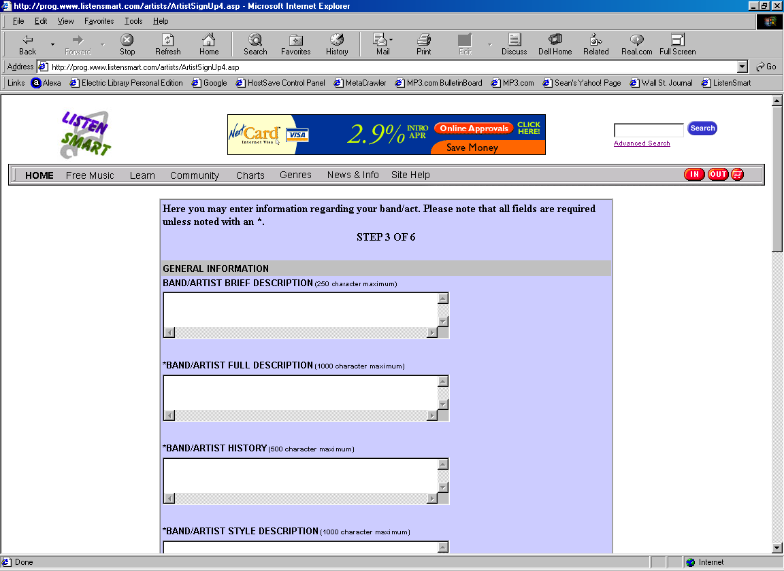
Figure 10: Sample Artist Signup Interview Procedures

Additionally, artists will have the capacity to edit their information at any time and can even add items to their home page such as:

- Gigs/Concerts
- Upcoming Events/Appearances
- "Good Things People Are Saying…"
- Links to other ListenSmart.com artists
- Etc.

Also during the interview process, the artists will have the opportunity to upload their songs or compositions to the ListenSmart.com server. During the upload, the artist will provide unique information regarding their song or composition including:

- Name
- Brief description
- Song/composition details
- Song Lyrics
- Song/composition keywords (for searches)
- Song credits
- Song Availability (downloadable or available for "preview" and purchase only)

Once ListenSmart.com receives all of the artist’s home page information, a company representative to insure legal compliance and to prevent the posting of offensive text or graphics will review it. Once reviewed, the artist's home page will be posted to the site using the URL www.listensmart.com/[artist name here]. Once their home page is posted, their presence is announced to the "virtual community" under a "new artists feature" column. Their URL will also be automatically submitted to over 100 major search engines using the keywords provided during the interview process.

To further aid the promotional efforts of the artist, ListenSmart.com will offer to host and store a fan email distribution list. Listener's who visit any artist's web page will find a field prompting them to be added to the artist's mailing list. Furthermore, should a user download or purchase a song or composition of the artists, they will also be prompted as to joining the artist's mailing list. The compiled list will be available to the artist at any time.

Artists will also have access to a statistics page that will allow them to evaluate their exposure and popularity on ListenSmart.com. Artist's statistics will include:

- Home page hits
- Total number of downloads (overall, by song, by day, and by month)
- Total number of previews (overall, by song, by day, and by month)
- Total number of CD sales (overall, by song, by day, and by month)
- Total number of accumulated email addresses
- Current artist rank overall, by genre, by song, by region, and by listener rating
- Current individual song or composition rank overall, by genre, by song, by region, and by listener rating
- Total Merchandise Sales (by day and by month)

Immediate Revenues
In addition to these potent promotional efforts on behalf of the artist, the other motivation for their participation will be immediate and future revenues. How an artist will be compensated will be determined by the level of participation an artist selects during the signup interview process. The three levels an artist can elect to participate are:

- Promotion Only
- Commerce Participation
- Revenue Sharing

An artist that elects "Promotion Only" participation declines any revenues through any channels and provides their material only for the additional exposure and promotion it will bring. A likely candidate for this type of participation would be an artist who has already signed a major recording contract, thus preventing them from offering merchandise, or their material via download or purchase, for fear of violating their agreement. They could, however, post a home page and offer their material in a low-fidelity streaming preview mode only without infringing on their agreement. Thus, they could take advantage of the exposure from the ListenSmart.com "virtual community." Conversely, ListenSmart.com would benefit from the added traffic brought to the site.

Artists that elect "Commerce Participation" allow their music and merchandise to be sold by ListenSmart.com and splitting the gross revenue of the sale 50/50. Artist earned revenues will be accumulated until the dollar amount equals or exceed $50, at which time the artist's primary contact will be sent a check for the amount. Artists will be able to track their earned revenues using their statistics page, and may apply part or all of their credits towards other products available through ListenSmart.com (including other artist's music and merchandise).

The most radical element of the ListenSmart.com business model is activated when the artist elects "Revenue Sharing" participation. Artists who elect this option effectively enter into a "partnering agreement" to make ListenSmart.com the contractual music publisher for their songs and/or compositions. For each song or composition, the artist will sign a standard single-song publishing contract that will entitle ListenSmart.com to 50% of the royalty revenues generated by the song for the life of the contract. This includes broadcast royalties, synchronization royalties (TV, Film, etc.), mechanical royalties (the selling of CD's, sheet music, etc.), grand rights (theater), and foreign royalties (for more on music publishing royalties, relationships, and contract, see the music publishing addendum).

In exchange for releasing their publishing rights to ListenSmart.com, the artist stands to earn considerable immediate and future revenues. In addition to the "Commerce Participation" method described above, "Revenue Sharing" artists will be distributed 50% of all advertising revenue earned by ListenSmart.com. Distribution amounts will be commensurate with the total amount of the artist's music that was downloaded, relative to all the other Revenue Sharing artists. The advertising revenues will be closely monitored and audited by an outside source and the total figures will be posted on an "artist only" page of the web site. This will create genuine excitement as the artists see their collective share continue to grow month after month. Distributions will be paid quarterly.

Future Revenues
Additionally, "Revenue Sharing" artists will have their music included in the SyncSmart.com database of music for movie, TV, film, or commercial synchronization material. This service will be promoted to film and video producers, advertising agencies, and music supervisors worldwide as an efficient means to find appropriate synchronization material for their project. Should a participating artist's song or composition be used for synchronization, a synchronization royalty would be negotiated, and the songwriter composer would earn 50% of the royalty and ListenSmart.com, LLC would earn 50% of the royalty.

Furthermore, major recording labels, producers, and other publishers, will be solicited and encouraged to frequent the ListenSmart.com community when searching for artists or material for new endeavors. Should a ListenSmart.com song/composition or artist be selected, the royalties from such an endeavor would be split 50% to the artist and 50% to ListenSmart.com, LLC, the music publisher of record.

As a bonus service to "Revenue Sharing" artists, ListenSmart.com will post the artists songs and information on every other MP3 or independent music site available, thus leveraging our own competition to promote our participating artists. We will also constantly monitor the Internet landscape for new sites or new opportunities to circulate our artist's songs and information. Should a worthy new site spring up, we will automatically submit our participating artists information. It is our feeling that the apparent contradiction of supporting our competition is far outweighed by the added exposure for our participating artists and the greater chance for music publishing royalties in the future. Also, this philanthropic approach will firmly ingratiate ListenSmart.com as the premiere tool and service for the development of rising artists. This approach of leveraging competitor’s resources for gain truly represents a rare example of "unfair competitive advantage" so often sought by investors.

ARTIST & REPERTOIRE PROMOTION
To fully maximize the potential of the ListenSmart.com business model, every effort must be made to exploit each revenue-sharing artist’s song to the maximum amount of revenue earning potential. This is achieved using a three-pronged attack from three different Internet websites (affectionately referred to as “SmartSuite”).

ListenSmart.com
The ListenSmart.com site proper is clearly a business-to-consumer (or artist-to-consumer) play. It has been demonstrated by MP3.com that a business cannot be sustained by the sale of individual CDs to consumer by relatively unknown artists. However, by eliminating the cost of obtaining music and by using the function of the virtual community, it will provide an environment of “musical Darwinism” where the music with the most inherent entertainment value will rise to the top. Thus, ListenSmart.com will become a clearinghouse for market tested artists and repertoire that will then be promoted in the “sister” business-to-business plays, SyncSmart.com and SmartAandR.com.

SyncSmart.com
ListenSmart.com’s "Revenue Sharing" participants will have their music included in the SyncSmart.com database of music for movie, TV, film, or commercial synchronization material. Similar to LicenseMusic.com, this business-to-business service will be promoted to film and video producers, advertising agencies, and music supervisors worldwide as an efficient means to find appropriate synchronization material for their project based on their specific criteria and budget. Information specific to songs is gathered in advance during the song signup procedure (i.e. mood, tempo, subject matter, language, etc.) that will facilitate the functionality of the site. Thus, a movie producer could visit the site looking for material that used the accordion, was a medium tempo, sung in Spanish, and pertained to beer and ghosts. Once the results are presented, the producer could preview each song then move forward the licensing process. Should a participating artist's song or composition be used for synchronization, a synchronization royalty would be negotiated, and the songwriter composer would earn 50% of the royalty and ListenSmart.com would earn 50% of the royalty.

SmartAandR.com
The second sister business-to-business play will be directed toward record labels, A&R representatives, and record producers looking for new material or to sign new talent. Visitors to the site will be able to search for new acts and songs by using criteria such as genre, region, touring ability, similar artists etc. Additionally, visitors will be able to utilize the clearinghouse function of ListenSmart.com by creating their own “success-factor index” based on the popularity charts found on ListenSmart.com. Thus, for example, a record producer could assign a value from 1-10 to indicate the importance of all the tracking functions:
- Top Downloads
- Highest Rated By Members
- Highest Rated By Artists
- Most Often Reviewed
- Most CD Sales
- Chosen Most for "Favorites"
- Most Home Page Visits
By applying this custom algorithm to their search criteria a perfect match can be found. Results will also display pertinent business information such as management, legal representation, touring experience/ability, etc. along with direct contact information.

The diagram below summarizes the ListenSmart.com business model.

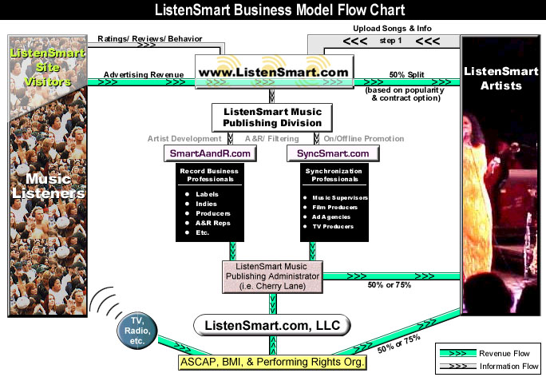
Figure 11: ListenSmart Business Model Flow Chart

Projections & Assumptions

Projections Summary At-a-Glance
Below is a snapshot summary of the significant ListenSmart projections. Each projection is thoroughly explained in the forecast notes later in the document.
First Year Website Traffic (Unique Visitors per Day)*
 | Month 1 | Month 2 | Month 3 | Month 4 | Month 5 | Month 6 | Month 7 | Month 8 | Month 9 | Month 10 | Month 11 | Month 12
ListenSmart | 4,800 | 9,600 | 14,400 | 19,200 | 24,000 | 28,800 | 33,600 | 38,400 | 43,200 | 48,000 | 52,800 | 56,000
*See page 4 for more details

Second Year Website Traffic (Unique Visitors per Day)*
 | Month 13 | Month 14 | Month 15 | Month 16 | Month 17 | Month 18 | Month 19 | Month 20 | Month 21 | Month 22 | Month 23 | Month 24
ListenSmart | 60,800 | 65,600 | 70,400 | 75,200 | 80,000 | 84,800 | 89,600 | 94,400 | 99,200 | 104,000 | 108,800 | 125,000
*See page 4 for more details

ListenSmart Projected Artist Enrollment* |  |  | Projected "Revenue Sharing" Artists*
Registered Artists end of 2 Years | 60,000 | X 50% = | Revenue Sharing Artists end of 2 Years | 30,000
Registered Artists end of 3 Years | 160,000 | X 50% = | Revenue Sharing Artists end of 3 Years | 80,000
Registered Artists end of 4 Years | 300,000 | X 50% = | Revenue Sharing Artists end of 4 Years | 150,000
*See pages 4-5 for more details

ListenSmart Five Year Revenue Projections*
 | Year 1 | Year 2 | Year 3 | Year 4 | Year 5
Music Publishing Revenue | $0 | $0 | $3,483,897 | $10,490,320 | $21,819,222
Banner Advertising Revenue | $992,250 | $4,179,000 | $7,365,750 | $10,552,500 | $13,739,250
Rich Media Advertising Revenue | $177,188 | $746,250 | $1,315,312 | $1,884,374 | $2,453,436
Newletter Sponsorship Revenue | $354,375 | $746,250 | $1,138,125 | $1,530,000 | $1,921,875
Opt-In Email Affiliate Revenue | $175,688 | $746,250 | $1,316,812 | $1,887,374 | $2,457,936
Affiliate Link Commission Revenue | $10,631 | $44,775 | $78,919 | $113,063 | $147,207
CD SalesRevenue | $63,788 | $268,650 | $473,512 | $678,374 | $883,236
Artist Merchandise Sales Revenue | $15,000 | $22,500 | $30,000 | $37,500 | $45,000
TOTAL | $1,788,920 | $6,753,675 | $15,202,327 | $27,173,505 | $43,467,162
*See pages 6-22 for more details

Key Assumptions*
Average Number of Revenue Sharing Songs per R/S Artist | 3
Percentage of Professionally Competitive R/S Songs/Artists | 15%
Percentage of Prof. Competitive R/S Songs/Artists That Will Be Signed | 5%
Average Synchronization License Fee | $1,000.00
Average Mechanical Royalty per Song | $ 0.06
*See page 6-16 for more details

Site Traffic
Our key to credible projections of both artist enrollment and general website traffic is to utilize the metrics of the most similar comparable. We believe that MP3.com – despite a fundamentally different business model – offers the best choice for comparison based on functional and categorical similarities. However, we are not insensitive to the vast branding advantage MP3.com has enjoyed by sheer choice of their domain name. Thus, projections and forecasts using MP3.com as a model have been reasonably adjusted downward to account for this phenomenon. Each respective adjustment is identified and described as they are applied to specific calculations herein.

Site Visitors
For this metric, we have put significant weight upon the vast branding advantage MP3.com has enjoyed by their domain name in attracting traffic to their site. Thus, we project to achieve only 20% of their reported traffic as demonstrated in the charts below.

First Year Website Traffic (Unique Visitors per Day)
 | Month 1 | Month 2 | Month 3 | Month 4 | Month 5 | Month 6 | Month 7 | Month 8 | Month 9 | Month 10 | Month 11 | Month 12
MP3.com | 24,000 | 48,000 | 72,000 | 96,000 | 120,000 | 144,000 | 168,000 | 192,000 | 216,000 | 240,000 | 264,000 | 280,000
ListenSmart | 4,800 | 9,600 | 14,400 | 19,200 | 24,000 | 28,800 | 33,600 | 38,400 | 43,200 | 48,000 | 52,800 | 56,000
Table 1: First Year Website Traffic

Second Year Website Traffic (Unique Visitors per Day)
 | Month 13 | Month 14 | Month 15 | Month 16 | Month 17 | Month 18 | Month 19 | Month 20 | Month 21 | Month 22 | Month 23 | Month 24
MP3.com | 304,000 | 328,000 | 352,000 | 376,000 | 400,000 | 424,000 | 448,000 | 472,000 | 496,000 | 520,000 | 544,000 | 596,000
ListenSmart | 60,800 | 65,600 | 70,400 | 75,200 | 80,000 | 84,800 | 89,600 | 94,400 | 99,200 | 104,000 | 108,800 | 125,000
Table 2: Second Year Website Traffic

Site Visitor-to-Artist Ratio
Trying to determine whether more website traffic attracts more artists, or more artists attract more website traffic presents a “chicken or the egg” predicament. Nevertheless, there is relatively consistent ratio of 5-10 daily visitors to every enrolled artist with MP3.com and also among other music sites that feature independent artists (i.e. Riffage.com, IUMA.com, AMP3.com, etc.). Nevertheless, we have conservatively factored a ratio of only 2 daily visitors for each registered artist in our website traffic forecasts.

Artist Enrollment
One of the key components to the ListenSmart forecasts and projections revolve around the number of bands and artists that elect to upload their music and material to the ListenSmart.com website for distribution. MP3.com was the first significant player to offer such a service, which it began in August, 1998. As of July 2000, MP3.com has registered approximately 88,000 artists over the course of 24 months. Although their overall website traffic, their first-mover advantage, and the inherent branding of their domain name has most certainly been a factor in achieving these numbers, ListenSmart has its own unique advantage. These 88,000 artists have already made their transition into the online music space for the sake of exposure and promotion. Furthermore, common sense suggests that their promotional efforts could be enhanced through an additional presence on ListenSmart, and at no cost to them. Also, part of the service ListenSmart will offer to incoming artists is to merely duplicate their information from another site to ListenSmart, thus requiring only their permission, and virtually no time or effort from the artist. Nonetheless, we reasonably expect to achieve 70% of the MP3.com artist enrollment metrics over our first 24 months. Thus, we project approximately 60,000 registered artist with ListenSmart.com at the end our second year.

Growth Rate
It is convenient to use the two operating years of MP3.com as a model for our two-year projections. However, to complete projections out through five years, we have to make certain assumptions with regards to the growth rate of new artists entering the online music space. By analyzing MP3.com’s total artist enrollment from the end of its first year (26,700) to the total artist enrollment from the end of its second year (88,000), a growth rate of 330% is determined.

MP3.com Artist Enrollment Growth Rate
 | Artists | Growth
End of first year | 26,700 | N/A
End of second year | 88,000 | +330%
Table 3: MP3.com Artist Enrollment Growth Rate
There is significant evidence to suggest that this growth rate will not only sustain, but also actually increase in the near future. For example, there are 64 million amateur musicians and over 1 million recording artists in the U.S. alone. Common sense suggests that at some point in the future, all of these recording artists will have their music available on the Internet in some capacity, and currently less than 100,000 have made their transition. Nonetheless, we have conservatively applied only 75% of the MP3.com growth rate to our years 3-5.

Artist Enrollment Summary
Thus, by using our projections of 60,000 registered artists after two years (based on 70% of the MP3.com total after two years) and applying 75% of MP3.com’s growth to subsequent years, we can determine the following projections for ListenSmart artist enrollment:

ListenSmart Projected Artist Enrollment
Number of Registered Artists end of 2 Years | 60,000
Number of Registered Artists end of 3 Years | 160,000
Number of Registered Artists end of 4 Years | 300,000
Table 4: ListenSmart Projected Artist Enrollment

Revenue Sharing Artists
Since the artists are given an option whether or not to assign one or more of their songs to the ListenSmart music publishing relationship, an assumption must be made with regards to the percentage of enrolled artists that will chose to do so. Anecdotal evidence from the current artist community suggests a high percentage will elect the publishing option, as these artists cite their motivation for registering with ListenSmart in the first place to be the unique music publishing and revenue sharing aspects. Nonetheless, we are conservatively projecting that at least 50% of enrolled artists will participate in the music publishing relationship for at least one song, thus becoming a “revenue sharing” artist.

ListenSmart Projected Artist Enrollment |  |  | Projected "Revenue Sharing" Artists
Registered Artists end of 2 Years | 60,000 | X 50% = | Revenue Sharing Artists end of 2 Years | 30,000
Registered Artists end of 3 Years | 160,000 | X 50% = | Revenue Sharing Artists end of 3 Years | 80,000
Registered Artists end of 4 Years | 300,000 | X 50% = | Revenue Sharing Artists end of 4 Years | 150,000
Table 5: ListenSmart Projected Revenue Sharing Artists

Publishing Revenue
Although the processes above help to determine general site traffic and the total number of artists that will elect the revenue sharing/music publishing option, additional assumptions must be made to credibly project music publishing revenues. When dealing with the “unfiltered” songwriter constituency as whole (that ListenSmart will attract to the site), it is virtually impossible to establish a single perfect formula that could indicate the "average" or "potential" level of success. Ultimately, however, our projections need to make this determination, thus we have built our projections upon several key assumptions, but also tied them to measurable benchmarks such as comparable metrics and SoundScan reports.

Key Assumptions
Our first step in projecting publishing revenues is to make several credible assumptions.

Average Number of Revenue Sharing Songs
Since a music publisher operates on a song-unit basis, an assumption must be made to determine the number of songs ListenSmart will add to its music publishing catalog. Anecdotal evidence from the current ListenSmart artist community suggests that most artists will participate in an all-or-nothing basis with regards to the publishing option of their songs, even though the option is on a song-by-song basis. Additionally, the average ListenSmart artist uploads 5.5 songs. Moreover, the average MP3.com artist uploads over 6 songs. Nevertheless, we have conservatively set the average number of revenue sharing songs (per revenue sharing artist) at 3 for the purpose of our publishing revenue projections.

Projected "Revenue Sharing" Artists |  | # of Songs | Projected "Revenue Sharing" Songs
End of 2 Years | 30,000 | X 3 = | End of 2 Years | 90,000
End of 3 Years | 80,000 | X 3 = | End of 3 Years | 240,000
End of 4 Years | 150,000 | X 3 = | End of 4 Years | 450,000
Table 6: Projected Revenue Sharing Songs

Percentage of Professionally Competitive Songs/Artists
Based on the operating experience of ListenSmart.com, as well as other independent music sites such as MP3.com, Riffage.com, and IUMA.com, a case could be made by industry veterans that 15% of the music uploaded to these sites (without a screening or filtration mechanism) could at least compete in a professional market space. Thus the 15% mark is considered our “target.”

Total "Revenue Sharing" Artists |  | Competitive | Competitive "Revenue Sharing" Artists
End of 2 Years | 30,000 | X 15% = | End of 2 Years | 4,500
End of 3 Years | 80,000 | X 15% = | End of 3 Years | 12,000
End of 4 Years | 150,000 | X 15% = | End of 4 Years | 22,500
Table 7: Competitive Revenue Sharing Artists

Percentage of Competitive Artists Signed
Of this narrowed-down 15% pool of artists, we must make another assumption of the percentage of these artists that will procure recording contracts or similar deals from either major or independent labels. These signings may come from our own online and offline promotional efforts, or they may also occur independent of our efforts. We are projecting that 5% of the (15%) commercially competitive artist pool will procure recording contracts or similar deals from either major or independent labels.

Competitive "Revenue Sharing" Artists |  | % of Deals | Total Signed to Recording Contracts
End of 2 Years | 4,500 | X 5% = | End of 2 Years | 225
End of 3 Years | 12,000 | X 5% = | End of 3 Years | 600
End of 4 Years | 22,500 | X 5% = | End of 4 Years | 1,125
Table 8: Total Artists Signed to Recording Contracts

Methodology
There are many revenue segments to the music publishing industry including mechanical royalties, performance royalties, synchronization royalties, and print royalties. The calculations above have focused on recording contracts, which have a direct relationship to mechanical royalties. Our approach is to first project U.S. CD sales from the pool of ListenSmart artists that become signed to recording contracts using SoundScan reports as a benchmark, thereby projecting revenues from U.S. mechanical royalties. We then use the U.S. mechanical royalty revenue as a constant to pro rate the additional segments of U.S. music publishing royalties (performance royalties, synchronization royalties, print royalties, etc.) based upon the relative percentages reported by the NMPA. We assume that the forces that drive the existence of mechanical royalties also drive the royalty generation of these other segments. Once we have established this total for all U.S. music publishing royalties, we then use this amount as a constant to pro-rate the projected publishing royalty revenue from the world market based upon the relative percentages reported by the NMPA. The diagram below illustrates the key steps in our methodology.

# of  Enrolled  Artists |  | # of  Competitive  Artists |  | # of  Competive  Artists  Signed |  | Sound-  scan  Bench-  Mark |  | U.S.  Mechanical  Royalty  Revenue |  | U.S.  Total  Publishing  Revenue |  | World Total Publishing Revenue

We have already determined projections up through the third step (# of competitive and signed ListenSmart artists), however, each subsequent step is given a greater explanation below.

Using SoundScan Reports as Success Benchmark
Soundscan Inc. tracks 85 percent of all retail music sales in the U.S. Its computers register sales information every time a compact disc, cassette or record is passed across a bar-code scanner at more than 15,000 outlets. The table below is from a Soundscan report of the 38,857 CDs released in 1999 and their breakdown by unit sales.

First Year Release Sales (for 1999)
# of Unit Sales | # of Releases | % of Total
1,000,000 | 52 | 0.13%
500,000 | 71 | 0.18%
250,000 | 110 | 0.28%
100,000 | 204 | 0.53%
50,000 | 261 | 0.67%
25,000 | 397 | 1.02%
20,000 | 189 | 0.49%
15,000 | 284 | 0.73%
10,000 | 531 | 1.37%
9,000 | 163 | 0.42%
8,000 | 208 | 0.54%
7,000 | 250 | 0.64%
6,000 | 318 | 0.82%
5,000 | 368 | 0.95%
4,000 | 571 | 1.47%
3,000 | 797 | 2.05%
2,000 | 1,283 | 3.30%
1,000 | 32,800 | 84.41%
TOTAL | 38,857 | 100%
Table 9: SoundScan First Year Release Sales Data for 1999
Thus, only 52 of the 38,857 (or .13%) CDs released in 1999 sold at least 1 million copies. The key figures for our calculations is the far right-hand column and their relationship to the tiers of the far left-hand column, which gives us a benchmark of individual CD sales performance from among the aggregate of all releases.

Applied to ListenSmart Song/Artist Assumptions
Since we have already projected the number of ListenSmart revenue sharing artists that will procure recording contracts in Table 8, we can then apply the SoundScan benchmark to these number – one year at a time – to predict CD sales performance.

Thus, the table below duplicates the SoundScan report from above, but with the addition of the two right-hand columns to indicate the number of ListenSmart revenue sharing artist and their respective CD sales.

The ListenSmart Artists column is determined by multiplying the “ % of Total” column by the Total of signed ListenSmart Artists (225). ListenSmart CD Sales column is then determined by multiplying the ListenSmart Artists column by the “# of Unit Sales” column (note: odd values in this column are caused by the rounding of decimal points in the Artists column).

3rd Year Projected CD Sales (first year releases)
 |  |  | ListenSmart
# of Unit Sales | # of Releases | % of Total | Artists | CD Sales
1,000,000 | 52 | 0.13% | 0.30 | 301,104
500,000 | 71 | 0.18% | 0.41 | 205,561
250,000 | 110 | 0.28% | 1 | 159,238
100,000 | 204 | 0.53% | 1 | 118,125
50,000 | 261 | 0.67% | 2 | 75,566
25,000 | 397 | 1.02% | 2 | 57,470
20,000 | 189 | 0.49% | 1 | 21,888
15,000 | 284 | 0.73% | 2 | 24,667
10,000 | 531 | 1.37% | 3 | 30,747
9,000 | 163 | 0.42% | 1 | 8,495
8,000 | 208 | 0.54% | 1 | 9,635
7,000 | 250 | 0.64% | 1 | 10,133
6,000 | 318 | 0.82% | 2 | 11,048
5,000 | 368 | 0.95% | 2 | 10,654
4,000 | 571 | 1.47% | 3 | 13,225
3,000 | 797 | 2.05% | 5 | 13,845
2,000 | 1,283 | 3.30% | 7 | 14,858
1,000 | 32,800 | 84.41% | 190 | 189,927
TOTAL | 38,857 | 100% | 225
  1,276,189
Table 10: 3rd Year Projected CD Sales (first year releases)
We then repeat this process for the fourth year, where in Table 8 we have already determined 600 ListenSmart revenue sharing artists would be signed to recording contracts…

4th Year Projected CD Sales (first year releases)
 |  |  | ListenSmart
# of Unit Sales | # of Releases | % of Total | Artists | CD Sales
1,000,000 | 52 | 0.13% | 1 | 802,944
500,000 | 71 | 0.18% | 1 | 548,164
250,000 | 110 | 0.28% | 2 | 424,634
100,000 | 204 | 0.53% | 3 | 315,001
50,000 | 261 | 0.67% | 4 | 201,508
25,000 | 397 | 1.02% | 6 | 153,254
20,000 | 189 | 0.49% | 3 | 58,368
15,000 | 284 | 0.73% | 4 | 65,780
10,000 | 531 | 1.37% | 8 | 81,993
9,000 | 163 | 0.42% | 3 | 22,652
8,000 | 208 | 0.54% | 3 | 25,694
7,000 | 250 | 0.64% | 4 | 27,022
6,000 | 318 | 0.82% | 5 | 29,462
5,000 | 368 | 0.95% | 6 | 28,412
4,000 | 571 | 1.47% | 9 | 35,268
3,000 | 797 | 2.05% | 12 | 36,920
2,000 | 1,283 | 3.30% | 20 | 39,622
1,000 | 32,800 | 84.41% | 506 | 506,472
TOTAL | 38,857 | 100% | 600
  3,403,171
Table 11: 4th Year Projected CD Sales (first year releases)
And finally, we repeat this process for the fifth year where we have already determined in Table 8 that 1,125 ListenSmart revenue sharing artists would be signed to recording contracts…

5th Year Projected CD Sales (first year releases)
 |  |  | ListenSmart
# of Unit Sales | # of Releases | % of Total | Artists | CD Sales
1,000,000 | 52 | 0.13% | 2 | 1,505,520
500,000 | 71 | 0.18% | 2 | 1,027,807
250,000 | 110 | 0.28% | 3 | 796,189
100,000 | 204 | 0.53% | 6 | 590,627
50,000 | 261 | 0.67% | 8 | 377,828
25,000 | 397 | 1.02% | 11 | 287,352
20,000 | 189 | 0.49% | 5 | 109,440
15,000 | 284 | 0.73% | 8 | 123,337
10,000 | 531 | 1.37% | 15 | 153,737
9,000 | 163 | 0.42% | 5 | 42,473
8,000 | 208 | 0.54% | 6 | 48,177
7,000 | 250 | 0.64% | 7 | 50,667
6,000 | 318 | 0.82% | 9 | 55,241
5,000 | 368 | 0.95% | 11 | 53,272
4,000 | 571 | 1.47% | 17 | 66,127
3,000 | 797 | 2.05% | 23 | 69,225
2,000 | 1,283 | 3.30% | 37 | 74,292
1,000 | 32,800 | 84.41% | 950 | 949,636
TOTAL | 38,857 | 100% | 1,125
  6,380,945
Table 12: 5th Year Projected CD Sales (first year releases)
All the above projections are based upon the assumption that a signed ListenSmart artist will release a new recording every year, and therefore we apply the SoundScan metrics of first year releases to each year (3,4, & 5). However, SoundScan also reports on back catalog sales. They define back catalog as any recording that is not its first year of release. Thus, to be completely accurate we need to repeat the process above for forecast years 4 & 5 to reflect the ListenSmart artists’ back catalog sales from releases in years 3 & 4.

Repeat Process for Back Catalog Sales in Years 4 & 5
Since our calculations begin with year 3, there is no back catalog to calculate in year 3. However in addition to the year 4 projections of first year releases from above, we now calculate below the back catalog sales of ListenSmart artists based upon the releases from year 3. Notice the changes to the benchmark for back catalog sales in “ # of Releases” column, as compared to the values from the first year releases benchmarks.

4th Year Projected CD Sales (Back Catalog Sales)
 |  |  | ListenSmart
# of Unit Sales | # of Releases | % of Total | Artists | CD Sales
1,000,000 | 88 | 0.03% | 0.08 | 76,916
500,000 | 112 | 0.04% | 0.10 | 48,946
250,000 | 219 | 0.09% | 0.19 | 47,854
100,000 | 599 | 0.23% | 1 | 52,355
50,000 | 979 | 0.38% | 1 | 42,784
25,000 | 1,728 | 0.67% | 2 | 37,759
20,000 | 831 | 0.32% | 1 | 14,527
15,000 | 1,289 | 0.50% | 1 | 16,900
10,000 | 2,397 | 0.93% | 2 | 20,951
9,000 | 745 | 0.29% | 1 | 5,860
8,000 | 888 | 0.34% | 1 | 6,209
7,000 | 1,047 | 0.41% | 1 | 6,406
6,000 | 1,385 | 0.54% | 1 | 7,263
5,000 | 1,782 | 0.69% | 2 | 7,788
4,000 | 2,483 | 0.96% | 2 | 8,681
3,000 | 3,619 | 1.41% | 3 | 9,489
2,000 | 6,152 | 2.39% | 5 | 10,754
1,000 | 13,876 | 5.39% | 12 | 12,128
100 | 66,881 | 25.98% | 58 | 5,846
TOTAL | 257,425 | 100% | 225
  439,547
Table 13: 4th Year Projected CD Sales (back catalog)

We repeat the back catalog process one more for the 5th year. Notice the total for the ListenSmart Artists column for the 5th year back catalog sales calculations are the sum of the releases from the 3rd year (225) and the 4th year (600), hence 825.

5th Year Projected CD Sales (Back Catalog Sales)
 |  |  | ListenSmart
# of Unit Sales | # of Releases | % of Total | Artists | CD Sales
1,000,000 | 88 | 0.03% | 0.28 | 282,024
500,000 | 112 | 0.04% | 0.36 | 179,470
250,000 | 219 | 0.09% | 0.70 | 175,464
100,000 | 599 | 0.23% | 2 | 191,969
50,000 | 979 | 0.38% | 3 | 156,876
25,000 | 1,728 | 0.67% | 6 | 138,448
20,000 | 831 | 0.32% | 3 | 53,264
15,000 | 1,289 | 0.50% | 4 | 61,965
10,000 | 2,397 | 0.93% | 8 | 76,819
9,000 | 745 | 0.29% | 2 | 21,488
8,000 | 888 | 0.34% | 3 | 22,767
7,000 | 1,047 | 0.41% | 3 | 23,488
6,000 | 1,385 | 0.54% | 4 | 26,632
5,000 | 1,782 | 0.69% | 6 | 28,555
4,000 | 2,483 | 0.96% | 8 | 31,830
3,000 | 3,619 | 1.41% | 12 | 34,795
2,000 | 6,152 | 2.39% | 20 | 39,432
1,000 | 13,876 | 5.39% | 44 | 44,470
100 | 66,881 | 25.98% | 214 | 21,434
1 | 150,325 | 58.40% | 482 | 482
TOTAL | 257,425 | 100% | 825
  1,611,172
Table 14: 5th Year Projected CD Sales (back catalog)

Determine Total Unit Sales
We can now extract the total CD unit sales from the all of the SoundScan benchmark tables above to project a grand total CD unit sales that include songs by ListenSmart artists in years 3, 4, and 5.

Total ListenSmart CD Unit Sales
 | 1st Yr. Releases | Back Catalog | Year Total
3rd Year | 1,276,189 | N/A | 1,276,189
4th Year | 3,403,171 | 439,547 | 3,842,717
5th Year | 6,380,945 | 1,611,672 | 7,992,617
Table 15: Total ListenSmart CD Unit Sales

Determine Mechanical Royalty Revenue
We can multiply the total number of CD releases that include songs by ListenSmart artists by the average number of revenue sharing songs per revenue sharing artist that we determined to be 3. Admittedly, this also assumes that each and every revenue sharing song would be included in the CD release of the signed ListenSmart artist.

 | Total CD Unit Sales | Avg. # of Songs per CD | Total Song Units Eligible for Mechanical Royalties
3rd Year | 1,276,189 | X 3 = | 3,828,567
4th Year | 3,842,717 | X 3 = | 11,528,152
5th Year | 7,992,617 | X 3 = | 23,977,850
Table 16: Total Song Units Eligible for Mechanical Royalties
At this point, we need to determine an average mechanical royalty. The current U.S. statutory rate for mechanical royalties for songs under five minutes in length is $.0755 per song, per recording. However, it is an extremely common industry practice for publishers to grant “controlled composition clauses,” which typically reduces the statutory rate to ¾ of the original. Since such a reduced rate would effectively make the mechanical royalty $.0566 per song, per recording, we have conservatively used $.06 as the average mechanical royalty when factoring in the blend of both full and reduced rates.

 | Total Song Units Eligible for Mechanical Royalties | Average Mechanical Royalty per Song | U.S. Mechanical Royalty Revenue
3rd Year | 3,828,567 | X $.06 = | $ 229,714.02
4th Year | 11,528,152 | X $.06 = | $ 691,689.14
5th Year | 23,977,850 | X $.06 = | $ 1,438,670.99
Table 17: U.S. Mechanical Royalty Revenue
These numbers effectively represent our projected U.S. mechanical royalty revenue.

Pro Rata
As mentioned above, there are many revenue segments to the music publishing industry in addition to the mechanical royalty revenues we have now determined in Table 17, including performance royalties, synchronization royalties, and print royalties.

Pro Rata of U.S. Publishing Revenue
Our next step is to use the U.S. mechanical royalty revenue as a constant to pro rate the additional segments of U.S. music publishing royalties (performance royalties, synchronization royalties, print royalties, etc.) based upon the relative percentages reported by the NMPA (again, we assume that the forces that drive mechanical royalties also largely drives the royalty generation from these other segments).

According to the National Music Publishers Association’s “Ninth Annual International Survey of Music Publishing Revenues,” the following breakdown is reflected for U.S. publishing royalties.

- Mechanical 33.07%
- Performance 44.00%
- Synchronization 6.91%
- Print & Misc. 15.4%

Thus, by using our U.S. mechanical royalties dollar values as a constant, we can effectively pro rate the other segments.

 | U.S. Mechanical  Royalty Revenue | U.S. Performance  Revenue | U.S. Sync  Revenue | U.S. Print & Misc.  Revenue | U.S. Publishing Revenue Year Total
 | 33.07% | 44.00% | 6.91% | 15.4% | 100%
3rd Year | $ 229,714.02 | $ 305,637.03 | $ 48,478.90 | $ 106,972.96 | $ 690,802.91
4th Year | $ 691,689.14 | $ 920,300.03 | $ 145,974.23 | $ 322,105.01 | $2,080,068.41
5th Year | $ 1,438,670.99 | $ 1,914,167.63 | $ 303,617.44 | $ 669,958.67 | $4,326,414.74
Table 18: U.S. Publishing Revenue Totals

Pro Rata of World Publishing Revenue
Now that we have established this total for U.S. music publishing revenues, we may now use these amounts as a constant to pro-rate the publishing royalties from the world market based upon the relative percentages reported by the NMPA.

According to the National Music Publishers Association’s “Ninth Annual International Survey of Music Publishing Revenues,” the following breakdown is reflected for the world publishing royalties.

- Mechanical 28.71%
- Performance 42.14%
- Synchronization 13.72%
- Print & Misc. 15.44%

We also know that the U.S. market represents 23% of the music publishing industry revenue total. Thus, by again using our U.S. mechanical royalties dollar values as a constant, we can effectively pro rate the world market.

 | World Mechanical  Royalty Revenue | World Performance  Revenue | World. Sync  Revenue | World Print & Misc.  Revenue | World Publishing Revenue Year Total
 | 28.71% | 42.14% | 13.72% | 15.44% | 100%
3rd Year | $ 998,756.59 | $1,465,956.21 | $ 482,060.95 | $ 537,123.01 | $ 3,483,896.76
4th Year | $ 3,007,344.08 | $4,414,123.29 | $1,451,527.98 | $ 1,617,324.72 | $10,490,320.08
5th Year | $ 6,255,091.27 | $9,181,105.76 | $3,019,089.19 | $ 3,363,936.23 | $21,819,222.46
Table 19: World Publishing Revenue Totals

Synchronization
Now that a total amount of revenue from synchronization royalties has been determined in Table 19, we can work backwards to determine the number of synchronization contracts that will be required to meet the target revenue numbers. We have used $1,000 as a very conservative average fee for synchronization contracts in our assumptions. This amount also includes the master use fee, which is a unique aspect to the publishing relationship we offer to revenue sharing artists.

 | Year 3 | Year 4 | Year 5
Assumed Total Synch Revenues | $ 482,060.95 | $1,451,527.98 | $3,019,089.19
Synch Licenses Required @ $1k ea. | 482 | 1,452 | 3,019
Table 20: Synchronization License Requirements

Advertising Revenue
Clearly, the long term revenue growth potential of ListenSmart is directly tied to music publishing revenues. However, advertising revenue will play an important role in the overall business model of ListenSmart (as 50% of which will be used to compensate revenue sharing artists), as well as generating a sustainable cash flow for the first few years.

Banner Advertising Revenue
We have categorically grouped together all potential advertisements or promotions that are displayed on fixed locations in web page real estate as banner advertising. They may include traditional 468 X 60 Banner ads (below) which may be displayed at the top and bottom of every ListenSmart page,


Figure 12: Sample 468x60 Banner Ad

and also special 100 x 100 promotion banners (below) that can be displayed in groups of twos and threes along the sides of web pages.


Figure 13: Sample 100x100 Promo Banner Ad

The tables below reflect our banner advertising revenue projections conservatively based upon having at least one 468 x 60 banner ad per page @ $15 CPM and one 100x100 promotional banner per page at $5 CPM. We have also assumed an average of seven page views per unique visitor, based upon the monthly metrics reported by MP3.com. Thus our formula for banner advertising revenue is as follows:

# of Monthly Visitors X 7 Page Views ea. X ($15 + $5)/1000

Notice that the projections reflect a steady growth of unique daily visitor through 125,000 in month 24 that we have determined earlier in Table 1 and 2.

First Year Banner Advertising Revenues
 | Month 1 | Month 2 | Month 3 | Month 4 | Month 5 | Month 6 | Month 7 | Month 8 | Month 9 | Month 10 | Month 11 | Month 12 | First Year TOTAL
Visitors Per Day | 2,000 | 3,000 | 4,500 | 6,750 | 10,000 | 15,000 | 20,000 | 25,000 | 30,000 | 35,000 | 40,000 | 45,000
Visitors Per Month | 60,000 | 90,000 | 135,000 | 202,500 | 300,000 | 450,000 | 600,000 | 750,000 | 900,000 | 1,050,000 | 1,200,000 | 1,350,000 | 7,087,500
Banner Advertising Revenue | $8,400 | $12,600 | $18,900 | $28,350 | $42,000 | $63,000 | $84,000 | $105,000 | $126,000 | $147,000 | $168,000 | $189,000 | $992,250.00
Table 21: Projected First Year Banner Advertising Revenues

Second Year Banner Advertising Revenues
 | Month 13 | Month 14 | Month 15 | Month 16 | Month 17 | Month 18 | Month 19 | Month 20 | Month 21 | Month 22 | Month 23 | Month 24 | TOTAL
Number of Visitors Per Day | 50,000 | 55,000 | 60,000 | 70,000 | 75,000 | 80,000 | 85,000 | 90,000 | 95,000 | 100,000 | 110,000 | 125,000
Number of Visitors Per Month | 1,500,000 | 1,650,000 | 1,800,000 | 2,100,000 | 2,250,000 | 2,400,000 | 2,550,000 | 2,700,000 | 2,850,000 | 3,000,000 | 3,300,000 | 3,750,000 | 29,850,000
Banner Advertising Revenue | $210,000 | $231,000 | $252,000 | $294,000 | $315,000 | $336,000 | $357,000 | $378,000 | $399,000 | $420,000 | $462,000 | $525,000 | $3,969,000
Table 22: Projected Second Year Banner Advertising Revenues

Rich Media Advertising
We have categorically grouped together all potential advertisements that includes audio, video, or animation as rich media advertising. This category of advertising is very attractive to advertisers as it allows them to break past the mundane banner ads in favor or a more compelling message. Moreover, rich media advertising is poised for explosive growth with the proliferation of broadband technologies. ListenSmart is poised perfectly for the delivery of rich media advertising since most of the media players that allow the for the delivery of music (i.e. RealPlayer, Windows Media Players, etc.), also allow for the delivery of audio, video, animation, and hyperlinks, all within the player’s browser window.

It is our plan to incorporate five-seconds of rich media advertising at the beginning of various radio-style playlists throughout the site. We will constantly monitor the users tolerance for additional rich media advertising within the middle of the playlists (i.e. every fifth song), however we plan to begin with only ads at the beginning for now.

Currently, rich media advertising delivery is allowing much higher CPM rates than banner ad impressions. The current industry standard for 5-10 second rich media spots is $50-$100 CPM. We have conservatively used the low end of $50 for the purposes of our projections.

The tables below reflect our rich media advertising revenue projections conservatively based upon having at least 50% of all visitors to the site triggering at least one playlist on average. Thus our formula for rich media advertising revenue is as follows:

# of Monthly Visitors X 50% X $50/1000

First Year Rich Media Advertising Revenues
 | Month 1 | Month 2 | Month 3 | Month 4 | Month 5 | Month 6 | Month 7 | Month 8 | Month 9 | Month 10 | Month 11 | Month 12 | First Year TOTAL
Visitors Per Day | 2,000 | 3,000 | 4,500 | 6,750 | 10,000 | 15,000 | 20,000 | 25,000 | 30,000 | 35,000 | 40,000 | 45,000
Visitors Per Month | 60,000 | 90,000 | 135,000 | 202,500 | 300,000 | 450,000 | 600,000 | 750,000 | 900,000 | 1,050,000 | 1,200,000 | 1,350,000 | 7,087,500
Rich Media Advertising Revenue | $1,500 | $2,250 | $3,375 | $5,063 | $7,500 | $11,250 | $15,000 | $18,750 | $22,500 | $26,250 | $30,000 | $33,750 | $177,188.00
Table 23: Projected First Year Rich Media Advertising Revenues

Second Year Rich Media Advertising Revenues
 | Month 13 | Month 14 | Month 15 | Month 16 | Month 17 | Month 18 | Month 19 | Month 20 | Month 21 | Month 22 | Month 23 | Month 24 | TOTAL
Number of Visitors Per Day | 50,000 | 55,000 | 60,000 | 70,000 | 75,000 | 80,000 | 85,000 | 90,000 | 95,000 | 100,000 | 110,000 | 125,000
Number of Visitors Per Month | 1,500,000 | 1,650,000 | 1,800,000 | 2,100,000 | 2,250,000 | 2,400,000 | 2,550,000 | 2,700,000 | 2,850,000 | 3,000,000 | 3,300,000 | 3,750,000 | 29,850,000
Rich Media Advertising Revenue | $37,500 | $41,250 | $45,000 | $52,500 | $56,250 | $60,000 | $63,750 | $67,500 | $71,250 | $75,000 | $82,500 | $93,750 | $746,250
Table 24: Projected Second Year Rich Media Advertising Revenues

Newsletter Sponsorships
In addition to collecting email addresses from registered artists and registered members, ListenSmart has built a method to aggregate the maximum number of email addresses possible for subscription to our monthly newsletter, and also for opt-in subscription to affiliate companies. Whenever a new users first attempts to listen to music (in any format) from an artist page, they are presented with the following dialog box:

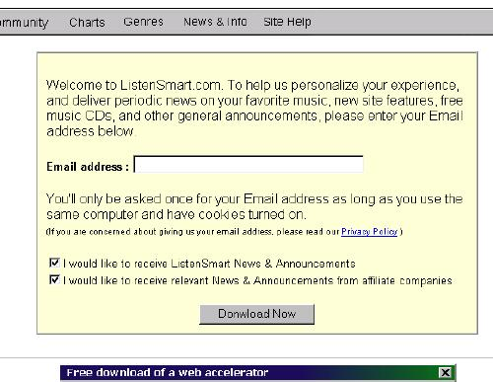
Figure 14: Download/Stream Request Dialog Box Screenshot

The user is only asked once for this information, at which time a cookie tells our servers to not ask for the information again. As you can see, the default options for both the monthly newsletter and also for the affiliate announcements is “yes.” Thus, we have projected that at least 50% of the visitors to the site will provide their email address for the purpose of subscribing to our monthly newsletter.

Space within our monthly newsletter can be monetized through sponsorships and related promotions. Industry standard CPM rates for such promotions are similar to, if not slightly higher, than the banner advertising rates.

The tables below reflect our newsletter sponsorship advertising revenue projections conservatively based upon only one advertisement at an industry standard rate of $25 per 1000 (CPM) and having at least 50% of all visitors subscribe to the monthly newsletter either by registering as a member, or completing the download/stream request dialog box. Thus our formula for newsletter sponsoship revenue is as follows:

# of Monthly Visitors X 50% X $25/1000

First Year Newsletter Sponsorship Advertising Revenues
 | Month 1 | Month 2 | Month 3 | Month 4 | Month 5 | Month 6 | Month 7 | Month 8 | Month 9 | Month 10 | Month 11 | Month 12 | First Year TOTAL
Visitors Per Day | 2,000 | 3,000 | 4,500 | 6,750 | 10,000 | 15,000 | 20,000 | 25,000 | 30,000 | 35,000 | 40,000 | 45,000
Visitors Per Month | 60,000 | 90,000 | 135,000 | 202,500 | 300,000 | 450,000 | 600,000 | 750,000 | 900,000 | 1,050,000 | 1,200,000 | 1,350,000 | 7,087,500
Newsletter Advertising Revenue | $3,000 | $4,500 | $6,750 | $10,125 | $15,000 | $22,500 | $30,000 | $37,500 | $45,000 | $52,500 | $60,000 | $67,500 | $354,375.00
Table 25: Projected First Year Newsletter Sponshorship Revenues

Second Year Newsletter Sponsorship Advertising Revenues
 | Month 13 | Month 14 | Month 15 | Month 16 | Month 17 | Month 18 | Month 19 | Month 20 | Month 21 | Month 22 | Month 23 | Month 24 | TOTAL
Number of Visitors Per Day | 50,000 | 55,000 | 60,000 | 70,000 | 75,000 | 80,000 | 85,000 | 90,000 | 95,000 | 100,000 | 110,000 | 125,000
Number of Visitors Per Month | 1,500,000 | 1,650,000 | 1,800,000 | 2,100,000 | 2,250,000 | 2,400,000 | 2,550,000 | 2,700,000 | 2,850,000 | 3,000,000 | 3,300,000 | 3,750,000 | 29,850,000
Newsletter Advertising Revenue | $75,000 | $82,500 | $90,000 | $105,000 | $112,500 | $120,000 | $127,500 | $135,000 | $142,500 | $150,000 | $165,000 | $187,500 | $1,492,500
Table 26: Projected Second Year Newsletter Sponshorship Revenues

Sale of Email Addresses to Opt-In Affiliates
Users who leave the second option checked in the dialog box are agreeing to receive email from ListenSmart affiliate companies. This opt-in arrangement allows ListenSmart to sell the email addresses in aggregate to qualified affiliates. The current industry standard sale price for opt-in email addresses is $.10 per name.

Please note that both the newsletter and the affiliate announcement options are opt-in relationships, and users may opt-out at any time.

The tables below reflect our revenue projections from the sale of email addresses to opt-in affiliates, conservatively based upon an industry standard rate of $0.10 per name and having at least 25% of all visitors assign opt-in affiliate permission by either by selecting the options when registering as a member, or while completing the download/stream request dialog box. Thus our formula for revenue from the sale of email addresses to opt-in affiliates is as follows:
# of Monthly Visitors X 25% X $0.10

First Year Sales to Opt-In Affiliates
 | Month 1 | Month 2 | Month 3 | Month 4 | Month 5 | Month 6 | Month 7 | Month 8 | Month 9 | Month 10 | Month 11 | Month 12 | First Year TOTAL
Visitors Per Day | 2,000 | 3,000 | 4,500 | 6,750 | 10,000 | 15,000 | 20,000 | 25,000 | 30,000 | 35,000 | 40,000 | 45,000
Visitors Per Month | 60,000 | 90,000 | 135,000 | 202,500 | 300,000 | 450,000 | 600,000 | 750,000 | 900,000 | 1,050,000 | 1,200,000 | 1,350,000 | 7,087,500
Sales to Opt-In Affiliate Revenue | $1,500 | $750 | $3,375 | $5,063 | $7,500 | $11,250 | $15,000 | $18,750 | $22,500 | $26,250 | $30,000 | $33,750 | $175,688.00
Table 27: Projected First Year Opt-In Affiliate Email Address Sales Revenues

Second Year Sales to Opt-In Affiliates
 | Month 13 | Month 14 | Month 15 | Month 16 | Month 17 | Month 18 | Month 19 | Month 20 | Month 21 | Month 22 | Month 23 | Month 24 | TOTAL
Number of Visitors Per Day | 50,000 | 55,000 | 60,000 | 70,000 | 75,000 | 80,000 | 85,000 | 90,000 | 95,000 | 100,000 | 110,000 | 125,000
Number of Visitors Per Month | 1,500,000 | 1,650,000 | 1,800,000 | 2,100,000 | 2,250,000 | 2,400,000 | 2,550,000 | 2,700,000 | 2,850,000 | 3,000,000 | 3,300,000 | 3,750,000 | 29,850,000
Sale to Opt-In Affiliate Revenue | $37,500 | $41,250 | $45,000 | $52,500 | $56,250 | $60,000 | $63,750 | $67,500 | $71,250 | $75,000 | $82,500 | $93,750 | $746,250
Table 28: Projected Second Year Opt-In Affiliate Email Address Sales Revenues

CD & Merchandise Sales + Affiliate Link Commissions
CD & Merchandise Sales + Affiliate Link Commissions represent a relatively small segment of the ListenSmart revenue projections. We consider these to be more “value-added services” for artists and users than significant profit centers for ListenSmart.

Affiliate Link Commissions
The tables below reflect our revenue projections from the sale of affiliate link commissions, conservatively based upon an assumption of 1 visitor per 1,000 clicking through to an affiliate site and making an average purchase of $15. We have also assumed a 10% average affiliate link commission. Thus our formula for affiliate link commission revenue is as follows:

# of Monthly Visitors X .1% X $15 X 10%

First Year Affiliate Link Commission Revenue
 | Month 1 | Month 2 | Month 3 | Month 4 | Month 5 | Month 6 | Month 7 | Month 8 | Month 9 | Month 10 | Month 11 | Month 12 | First Year TOTAL
Visitors Per Day | 2,000 | 3,000 | 4,500 | 6,750 | 10,000 | 15,000 | 20,000 | 25,000 | 30,000 | 35,000 | 40,000 | 45,000
Visitors Per Month | 60,000 | 90,000 | 135,000 | 202,500 | 300,000 | 450,000 | 600,000 | 750,000 | 900,000 | 1,050,000 | 1,200,000 | 1,350,000 | 7,087,500
Affiliate Link Commission Revenue | $90 | $135 | $203 | $304 | $450 | $675 | $900 | $1,125 | $1,350 | $1,575 | $1,800 | $2,025 | $10,631.00
Table 29: Projected First Year Affiliate Link Sales Revenues

Second Year Affiliate Link Commission Revenue
 | Month 13 | Month 14 | Month 15 | Month 16 | Month 17 | Month 18 | Month 19 | Month 20 | Month 21 | Month 22 | Month 23 | Month 24 | TOTAL
Number of Visitors Per Day | 50,000 | 55,000 | 60,000 | 70,000 | 75,000 | 80,000 | 85,000 | 90,000 | 95,000 | 100,000 | 110,000 | 125,000
Number of Visitors Per Month | 1,500,000 | 1,650,000 | 1,800,000 | 2,100,000 | 2,250,000 | 2,400,000 | 2,550,000 | 2,700,000 | 2,850,000 | 3,000,000 | 3,300,000 | 3,750,000 | 29,850,000
Affiliate Link Revenue | $2,250 | $2,475 | $2,700 | $3,150 | $3,375 | $3,600 | $3,825 | $4,050 | $4,275 | $4,500 | $4,950 | $5,625 | $44,745
Table 30: Projected Second Year Affiliate Link Sales Revenues

CD Sales
The tables below reflect our revenue projections from on-demand artist CD sales conservatively based upon an assumption of 1 visitor per 1,000 making a CD purchase with an average price of $9. Thus our formula for CD sales revenue is as follows:

# of Monthly Visitors X .1% X $9

First Year CD Sales Revenue
 | Month 1 | Month 2 | Month 3 | Month 4 | Month 5 | Month 6 | Month 7 | Month 8 | Month 9 | Month 10 | Month 11 | Month 12 | First Year TOTAL
Visitors Per Day | 2,000 | 3,000 | 4,500 | 6,750 | 10,000 | 15,000 | 20,000 | 25,000 | 30,000 | 35,000 | 40,000 | 45,000
Visitors Per Month | 60,000 | 90,000 | 135,000 | 202,500 | 300,000 | 450,000 | 600,000 | 750,000 | 900,000 | 1,050,000 | 1,200,000 | 1,350,000 | 7,087,500
CD Sales Revenue | $540 | $810 | $1,215 | $1,823 | $2,700 | $4,050 | $5,400 | $6,750 | $8,100 | $9,450 | $10,800 | $12,150 | $63,788.00
Table 31: Projected First Year CD Sales Revenues

Second Year CD Sales Revenue
 | Month 13 | Month 14 | Month 15 | Month 16 | Month 17 | Month 18 | Month 19 | Month 20 | Month 21 | Month 22 | Month 23 | Month 24 | TOTAL
Number of Visitors Per Day | 50,000 | 55,000 | 60,000 | 70,000 | 75,000 | 80,000 | 85,000 | 90,000 | 95,000 | 100,000 | 110,000 | 125,000
Number of Visitors Per Month | 1,500,000 | 1,650,000 | 1,800,000 | 2,100,000 | 2,250,000 | 2,400,000 | 2,550,000 | 2,700,000 | 2,850,000 | 3,000,000 | 3,300,000 | 3,750,000 | 29,850,000
CD Sales Revenue | $13,500 | $14,850 | $16,200 | $18,900 | $20,250 | $21,600 | $22,950 | $24,300 | $25,650 | $27,000 | $29,700 | $33,750 | $268,650
Table 32: Projected Second Year CD Sales Revenues

Artist Merchandise Sales
We project artist merchandise sales revenue to represent less than $50,000 over the first two years.

Two Year Revenue Totals
The charts below extract the total values from Tables 21-32 to indicate the two-year revenue projections for ListenSmart on a month-by-month basis.

First Year Revenue Projections (All Sources)
 | Month 1 | Month 2 | Month 3 | Month 4 | Month 5 | Month 6 | Month 7 | Month 8 | Month 9 | Month 10 | Month 11 | Month 12 | TOTAL
Banner Advertising Revenue | $8,400 | $12,600 | $18,900 | $28,350 | $42,000 | $63,000 | $84,000 | $105,000 | $126,000 | $147,000 | $168,000 | $189,000 | $992,250
Rich Media Advertising Revenue | $1,500 | $2,250 | $3,375 | $5,063 | $7,500 | $11,250 | $15,000 | $18,750 | $22,500 | $26,250 | $30,000 | $33,750 | $177,188
Newletter Sponsorship Revenue | $3,000 | $4,500 | $6,750 | $10,125 | $15,000 | $22,500 | $30,000 | $37,500 | $45,000 | $52,500 | $60,000 | $67,500 | $354,375
Opt-In Email Affiliate Revenue | $1,500 | $750 | $3,375 | $5,063 | $7,500 | $11,250 | $15,000 | $18,750 | $22,500 | $26,250 | $30,000 | $33,750 | $175,688
Affiliate Link Commission Revenue | $90 | $135 | $203 | $304 | $450 | $675 | $900 | $1,125 | $1,350 | $1,575 | $1,800 | $2,025 | $10,631
CD SalesRevenue | $540 | $810 | $1,215 | $1,823 | $2,700 | $4,050 | $5,400 | $6,750 | $8,100 | $9,450 | $10,800 | $12,150 | $63,788
Artist Merchandise Sales Revenue | $225 | $113 | $169 | $244 | $375 | $563 | $844 | $1,219 | $1,875 | $2,813 | $2,813 | $3,750 | $15,000
TOTAL | $15,255 | $21,158 | $33,986 | $50,970 | $75,525 | $113,288 | $151,144 | $189,094 | $227,325 | $265,838 | $303,413 | $341,925 | $1,788,919
Table 33: Projected First Year Revenues (All Sources)

Second Year Revenue Projections (All Sources)
 | Month 13 | Month 14 | Month 15 | Month 16 | Month 17 | Month 18 | Month 19 | Month 20 | Month 21 | Month 22 | Month 23 | Month 24 | TOTAL
Banner Advertising Revenue | $210,000 | $231,000 | $252,000 | $294,000 | $315,000 | $336,000 | $357,000 | $378,000 | $399,000 | $420,000 | $462,000 | $525,000 | $4,179,000
Rich Media Advertising Revenue | $37,500 | $41,250 | $45,000 | $52,500 | $56,250 | $60,000 | $63,750 | $67,500 | $71,250 | $75,000 | $82,500 | $93,750 | $746,250
Newsletter Sponsorship Revenue | $37,500 | $41,250 | $45,000 | $52,500 | $56,250 | $60,000 | $63,750 | $67,500 | $71,250 | $75,000 | $82,500 | $93,750 | $746,250
Opt-In Email Affiliate Revenue | $37,500 | $41,250 | $45,000 | $52,500 | $56,250 | $60,000 | $63,750 | $67,500 | $71,250 | $75,000 | $82,500 | $93,750 | $746,250
Affiliate Link Commission Revenue | $2,250 | $2,475 | $2,700 | $3,150 | $3,375 | $3,600 | $3,825 | $4,050 | $4,275 | $4,500 | $4,950 | $5,625 | $44,775
CD Sales Revenue | $13,500 | $14,850 | $16,200 | $18,900 | $20,250 | $21,600 | $22,950 | $24,300 | $25,650 | $27,000 | $29,700 | $33,750 | $268,650
Artist Merchandise Sales Revenue | $1,875 | $1,875 | $1,875 | $1,875 | $1,875 | $1,875 | $1,875 | $1,875 | $1,875 | $1,875 | $1,875 | $1,875 | $22,500
TOTAL | $340,125 | $373,950 | $407,775 | $475,425 | $509,250 | $543,075 | $576,900 | $610,725 | $644,550 | $678,375 | $746,025 | $847,500 | $6,753,675
Table 34: Projected Second Year Revenues (All Sources)

Marketing
Thus far, this document has discussed forecasts of artist enrollment, general website traffic, and the related revenue projections associated with those forecasts. This section is designed to illustrate our marketing plan that will allow us to achieve our forecasts with a reasonable and modest marketing budget.

Acquisition Costs
The key to our marketing plan is to identify a “target” acquisition cost for each of the following categories:

- Enrolled Artists
- Registered Members (and each of their respective song ratings & reviews)
- General site visitors

In doing so, our plan is launch a marketing campaign that allows us to achieve our objectives using a viral scheme, which also allows us to pay only for results, thereby eliminating the risk of typical advertising campaigns.

Artist Acquisition Cost
We have set our acquisition cost at $25 for each artist that uploads their music and information to our site, regardless of the revenue sharing status.

Registered Member (User) Acquisition Cost
A registered member is given a free ListenSmart member page to customize, upload pictures to, and use as a center of site functionality. As part of the signup process, registered members (optionally) provide ListenSmart with valuable demographic information. We have set our registered member acquisition cost at $5. Furthermore, we would like to maintain a ratio of at least 2½ registered members per enrolled artist to ensure a robust music listening community. Moreover, it is important for our registered members to provide feedback on the songs they listen to on the site in the form of song ratings and reviews. This feedback helps to determine song/artist prominence on the site, and will also help our publishing staff determine which songs are receiving significant attention. Although this behavior occurs with some individuals without incentive of any kind, our plan is to incentivize the process to maximize the output of this program. We have set our song rating and review acquisition cost at $0.25 per rating/review.

General Site Visitor Acquisition Costs
Many visitors to the site will not elect to become registered members, but are still vital and valuable in developing our branding and web presence, in addition to driving the advertising dollars. We have set our general site visitor acquisition cost at $.03. More specifically, we are willing to pay $.03 for every referring link to our site.

Affiliate Marketing
Now that our total acquisition exposure cost for each individual category has been determined, we plan to implement these numbers into a multi-level affiliate marketing compensation system that takes advantage of viral marketing components that can be so effective on the Internet.

Our plan is to make any and every registered artist or member of the site an affiliate marketer by offering a fixed commission for referring additional artists, members, or general site traffic in addition to creating new song ratings and reviews. The viral element is enhanced with the multi-level structure of the commission system, whereby override commissions are paid down through four levels. The aggregate sum of all levels is equal to the maximum acquisition costs we have set for in the section above. The commission structure is outlined in the table 35 below.

 | Level 1 | Level 2 | Level 3 | Level 4 | TOTAL  EXPOSURE
Breakdown | 60% | 25% | 10% | 5%
Artists | $ 15.00 | $ 6.25 | $ 2.50 | $ 1.25 | $ 25.00
Members | $ 3.00 | $ 1.25 | $ 0.50 | $ 0.25 | $ 5.00
Reviews | $ 0.15 | $ 0.06 | $ 0.03 | $ 0.01 | $ 0.25
Table 35: Affiliate Marketing Commission Structure
Additionally, any affiliate that uses a specially tagged and prepared hyperlink to ListenSmart.com will receive $.03 per referral. Affiliate links will not be subject to the multi-level commission structure.

The table below indicates the total affiliate marketing budget that would be required to achieve our projections. The table conservatively assumes that a commission would be paid on each and every acquisition, which is highly unlikely.

Affiliate Marketing Costs -- Years 1 + 2
 | Projected | Acquisition  Costs | Total Exposure | Comments
Artists | 60,000 | $ 25.00 | $ 1,500,000.00
Members | 150,000 | $ 5.00 | $ 750,000.00 | Assumes 2.5 members per artist
Reviews | 90,000 | $ 0.25 | $ 22,500.00 | Assumes 2 reviews per song
Site Visitors | 20,000,000 | $ 0.03 | $ 600,000.00 | Assumes 50% of total traffic is referred
TOTAL |  |  | $ 2,872,500.00
Table 36: Total Affiliate Marketing Costs -- Years 1 + 2
Thus, the conservative average annual marketing costs to achieve our two-year projections are approximately $1.4 million per year.

Commission checks will be distributed quarterly using the electronic business services of Pay Pal’s X.com. By presenting X.com with a spreadsheet of accounts payable, X.com can deliver the payments to the affiliates via email. Affiliates that receive these payments via email can set up a free account with X.com (if they’re not already a member), and have the funds transferred to their bank account electronically or request that X.com send them a physical check. This entire process is offered at zero cost, thereby drastically reducing the fulfillment costs of offering such a program.

As an additional bonus for ListenSmart, Pay Pal’s X.com is currently offering their own affiliate referral commission of $5 for each new registered user of their free service. Since ListenSmart will require this enrollment as a prerequisite to receiving commission payments – and since the majority of ListenSmart affiliate marketers are probably not yet registered members – ListenSmart stands to effectively reduce its acquisition cost by $5 per registered affiliate marketer.

Misc. Forecast Notes
Several issues are addressed below that are relevant to the overall evaluation of the ListenSmart revenue projections and forecasts, that otherwise did not belong in other sections of the document.

Potential Increases to Revenue Projections
Every attempt has been made to keep the music publishing revenue projections presented herein as conservative as possible, in some cases to the extreme. For the sake of balance, however, we would like to identify several factors that could potentially make the actual revenue numbers much more attractive.

1997 Publishing Industry Metrics
Many of the assumptions herein are based upon data compiled mostly from the 9th Annual National Music Publishers Association (NMPA ) Internaional Survey of Music Publishing Revenues. Although the survey is done annually, 1997 is the most current year of data available. Thus, the revenue projections presented herein should be considered inherently conservative, as the music publishing industry has shown steady and consistent growth, as evidence from the NMPA Survey chart below:

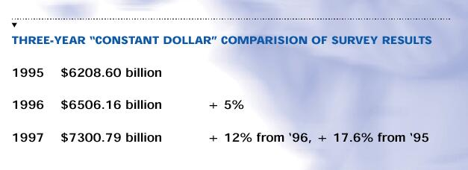
Figure 15: NMPA Survey of Music Publishing Revenue Growth

Explosive Synchronization Growth
Most experts agree that the music publishing segment poised for the most significant growth in the near future is synchronization royalties. The logic behind the assumption is directly connected to the exploding proliferation of broadband and wireless technologies. As high-speed connectivity becomes ubiquitous, web designers will be compelled to make their sites become a richer experience for the user, which would most likely include the use of music. Such music, of course, would require synchronization licenses.

Untapped Potential of the Internet for Music Distribution
A thorough account of all the untapped potential of the music industry with regards to digital distribution would encompass an entire document. Nevertheless, many experts agree that the industry is poised to explode out of its $40 billion per year shell into a $100 billion per year industry. New licensing arrangements, advertising/sponsorship relationships, and new business models (such as subscriptions) could help fuel the growth. Furthermore, the Internet has the capacity to shatter the mass-media bottleneck that has prevented so much worthy music from finding its audience up until now. Microtrends in programming and delivery will help to breathe new life into a stale system.

Number of MP3.com artists signed
A common query of those presented with an overview of the ListenSmart business model relates to the commercial music successes of MP3.com artists. We would like to address such a concern here. Firstly, just within the past 12 months, there have been a significant number of deals signed by MP3.com and other independent artists from the web. Below are links to just a sample.

Fisher signed to major label recording deal with Universal:
http://www.time.com/time/everyone/magazine/sidebar_music.html

Gunburner signed to major label recording deal with Columbia:
http://bboard.mp3.com/mp3/ubb/Forum53/HTML/000023.html

Soma Sonic signed to major label recording deal with Universal:
http://bboard.mp3.com/mp3/ubb/Forum53/HTML/000133.html

Amy Fairchild signed to major label development deal with Atlantic:
http://bboard.mp3.com/mp3/ubb/Forum53/HTML/000183.html

Dynamite Hack, Sonique, & SEV all signed to Universal's FarmClub.com
http://fclaweb01.dev.farmclub.com/fcfamily/signed.shtml

Monovox awarded $250,000 recording contract:
http://www.garageband.com/htdb/companyinfo/PressReleaseMonovox.html

Boondogs awarded $250,000 recording contract:
http://www.garageband.com/htdb/companyinfo/pressreleaseWinner.html

However, these are only indications of major label signings, and independent label signings (which are still of value to the ListenSmart business model) are seldom made public.

Secondly, since MP3.com was the first mover in the space, they – by default – attracted an inordinately high percentage of tech-savvy artist that were capable of converting their own music into MP3 song files and walking through the artist-signup procedures. In their early months, this translated to a predominance of electronic, dance, and techno artists, which currently have less commercial viability than other genres.

The development of user-friendly software, and more user-friendly web application developments have recently eliminated such a disparity, and all genres appears to be entering the online music space relative to the percentage of their offline existence.

Lastly, a consideration needs to be made with regards to the fundamental differences in business models between ListenSmart and MP3.com that would have an impact on such a comparison.

MP3.com is an advertising-revenue driven business model that focuses on website traffic as opposed to specifically targeting independent artists with commercial potential. Thus, as an eyeball aggregator their concern is not the quality of the artists, but rather the quantity.

One of the ListenSmart initiatives will be to make a significant effort to individually seek out promising artists and persuade them to form a music publishing relationship with ListenSmart. Once the music publishing relationship is in place, we expect to perform significant online and offline promotional efforts to facilitate and maximize the royalty-earning potential of the publishing catalog. MP3.com has no such financial incentive to provide this type of service, thus any signings from their artist community has come in spite of them.

MANAGEMENT
The management team of ListenSmart.com, LLC brings together a wealth of experience and accomplishments in the business, music, Internet, e-commerce, finance, and high technology industries. Each individual is a seasoned professional dedicated to creating a successful company, creating a new and meaningful virtual online music community, and making significant contributions to the new trends in digital music distribution. Each member of the management is also a successful entrepreneur, each having successfully launched and managed one or more companies. The management and technical teams at ListenSmart.com are a highly enthusiastic and intense group of individuals. Each member contributes fresh and unique ideas about the direction of online digital music and the peripheral business surrounding it.

Sean P. Fenlon, President & CEO
Sean P. Fenlon is a lifelong hi-tech musician who has studied with the finest teachers at the finest institutions including The Peabody Institute of Music where he is completing his Doctorate. Mr. Fenlon plays the bassoon and piano and is well regarded as a composer of jazz influenced electronic and computer music. He has had experience with the Internet in the digital music arena from its inception. In the business world – as the Director of Business Operations of Investors Mortgage Corporation (Columbia, MD) – Mr. Fenlon upgraded the technology and procedural standards of the operation, which helped to increase the overall revenues from $2,000,000 to $5,000,000 per annum during his two-year tenure. Mr. Fenlon is the creative visionary and the driving force behind the ListenSmart.com model and function.

Peter Lubin, VP of A&R
Mr. Lubin is a veteran Artist & Repertoire executive in the recording industry. Following stints as a publicist at The Howard Bloom Organization and at Columbia Records, Mr. Lubin was hired by Mercury Records (Polygram, Inc.) as Director of A&R in 1980. Over the next eight years, he signed many artists to the label including The Moody Blues, Peter Gabriel, Michelle Shocked, and Robert Cray. He also worked closely with a wide variety of artists such as Rush, Kool & The Gang, John Mellencamp, and The Everly Brothers. He was promoted to Vice-President in 1987.

Moving to Elektra Entertainment (Time Warner, Inc.) in 1988, Mr. Lubin acquired both The Pixies and The Breeders for the company, helped bring They Might Be Giants and Phish to the label, and worked closely with label artists Jackson Browne, Simply Red, and Huey Lewis, among others. He was promoted to Senior Vice-President of A&R in 1991.

Mr. Lubin returned to Mercury Records in 1995, again as Senior Vice-President of A&R, where he supervised all artist acquisitions and recording activities, and signed The Refreshments- the ninth best selling new artist of 1996. He left the label in 1997, and prior to joining ListenSmart.com has worked as an A&R consultant to various record labels, on-line companies, and media start-ups. He also serves on the Board of Directors of Digital Media On Demand, Inc.

Hyun Lee, CTO
Hyun Lee is the founder of Netronics Inc., a company specializing in web application development and consulting. Having earned a degree in Electrical Engineering at Georgia Institute of Technology (Georgia Tech), Hyun Lee has years of experience as an Internet application developer and web business solution provider including Bell Atlantic intranet applications, Korean Department of Defense intranet solutions, and Koreatimes.com. Mr. Lee also has years of experience and knowledge in system architecture, programming, and network design on a variety of platforms.

David Seidl, VP Strategic Development/Legal Counsel
David Seidl has been a practicing corporate law attorney since 1982. Educated at Loyola College (B.A., cum laude, 1978; M.B.A., with honors, 1983) and The University of Maryland (J.D., with honors, 1982), Mr. Seidl is an equity partner with the prestigious Baltimore law firm Miles & Stockbridge. In addition to his law practice, Mr. Seidl has launched several successful business endeavors including a chain of "Momma Illardos" pizzeria restaurants and a thriving investment group.

BOARD OF DIRECTORS
ListenSmart.com is committed to forming a strong Board of Directors that will provide our business the experience and sources of funding necessary for us to prosper. At this time, we have secured verbal board seat agreements from three of the most significant players in online/new-media space, Jim Griffin, Ted Cohen, and Paul Bandrowski. A brief bio of each is listed below.

Jim Griffin
Jim Griffin is the founder and CEO of Cherry Lane Digital LLC and OneHouse LLC. Cherry Lane Digital is dedicated to the digital delivery of art with an emphasis on the transition from the analog marketplace to the digital market space. OneHouse LLC provides such services as consulting, management and implementation of entertainment technology projects. Both companies serve entertainment companies who need help marketing products and services via digital delivery. Says Griffin, "entertainment is transitioning from a product to a service, and we help our clients to make that transition."

Called an "entertainment technology visionary" by the Los Angeles Times, Griffin got his start in the field as Director of Technology at Geffen Records, a post he held from 1993 to 1998. There he created and ran the label's technology department, rated by Network World as one of the top 7 technology departments in the United States, and one of the top 25 worldwide. Among Griffin's accomplishments at Geffen were digitizing the first full-length commercial entertainment product released online (Aerosmith's "Head First", 06/94), and developing Geffen World, one of the first corporate Intranet sites.

Griffin is quoted frequently regarding digital delivery of art, electronic commerce and Internet/Intranet issues in major publications. He is called upon regularly to speak at industry events, and at major universities. Recent engagements include Harvard Business School, GiGa Conference, Haas School of Business, UCLA, USC, Andersen Consulting, and Cambridge Technology Partners. Griffin sits on advisory boards for the USC Annenberg School of Communications and the American Film Institute.

In his spare time, Griffin created "Pho" which is a gathering point for entertainment industry and technology people which enables these two sectors to absorb uncertainties they have about one another and share information and perspectives. Started in Los Angeles, "Pho" members convene each Sunday afternoon for a two-hour brunch, where at least two dozen participants are regulars. Additionally, Pho maintains a mailing list for the community to carry on their discourse daily. Presently there are 150 subscribers to the mailing list. Pho brunches have spread from Seattle to New York.

Ted Cohen

Cohen is a 25-year veteran of the music industry and has served as a vice president for both Warner Bros. Records and Philips Media. Most recently, Cohen has run a highly successful, independent new media consulting operation, attracting clients like Amazon.com, Microsoft, Universal Studios New Media, DreamWorks Records, Liquid Audio, Wherehouse Entertainment and many other entertainment, computer and new media organizations. Cohen is considered a leader in the new media/music field. He has been a figurehead to a host of high-profile music conferences, including the first conference to ever deal exclusively with music and the Internet. He served as chairman of the highly successful Webnoize '98 & ’99 Conferences, and is considered one of the most well-connected players operating in the space. Most recently, Ted has been appointed to be VP of New Media for EMI Recorded Music in Los Angeles.

Paul Bandrowski

Paul Bandrowski is CEO of Reciprocal, one of the pioneering companies in the digital rights management market. Paul recognized early on the problem of intellectual property rights in the digital world, and combined his extensive knowledge of this subject, his technical know-how and his vision of the Internet's possibilities to co-found the Company. Reciprocal now deploys its digital rights management solution across vertical industries, enabling its clients, such as those in the music industry, to create new business models and revenue opportunities for their high-value content. Prior to founding Reciprocal, Paul was Chief Technology Officer for SOFTBANK Services Group, where he was responsible for the company's technology and service offerings. Before joining SOFTBANK, he was Director of Advanced Technology for worldwide operations of the Sara Lee Corporation. He has also founded and served as President and CEO of several other successful start-up companies. A sought-after speaker, Paul addresses groups frequently on issues relating to copyright protection, emerging technologies, and digital rights management.

CAPITALIZATION

Current Status & General Need for Capital
ListenSmart.com, LLC was incorporated on 8/23/99 as a Limited Liability Corporation. Our corporate headquarters is 5500sq. ft. “Class A” office space in Columbia, MD (approx. ½ way between Baltimore & Washington D.C.) capable of comfortably containing up to 30 employees plus CD production and fulfillment requirements. Currently, we are approximate eight weeks into the “soft launch” of a prototype beta web site. We have secured a $5 million pre-money valuation via $500,000 in angel-round investment from eight private equity-based investors, and an additional $250,000 in seed capital to support the “soft launch” of our beta site. We will be securing a second-round equity investment of $1-2 million within the next 6-8 weeks. We are also seeking additional beneficial working relationships with several key strategic partners.

Market Position & Opportunity
We expect our company to become a leader in a large or rapidly expanding market, with opportunity for substantial future revenue and earnings. The market potential and company valuation imply significant financial upside in the deal for both the investor and the company. We will be operating in a very large, demand-driven market where the company can realistically achieve revenues of between $50 million and $100 million within 3 to 5 years. We feel as though Internet-based digital music is a product that addresses a very dynamic market with high growth rates and substantial size. We also feel as though we have given careful and thoughtful assessment of the risks of the target market sector and those inherent in early stage companies.

Exit Strategy& Use of Startup Capital
We feel as though we have created a focused, cost-effective development strategy with realistic definable milestones and a pragmatic and credible business model that can deliver attractive financial results. Although, we feel as though our business model could sustain its own growth through cash-flow in the private sector, we understand the concerns of early-round investors to achieve liquidity.

The primary uses of startup capital for ListenSmart.com, LLC are as follows:

- To create a business infrastructure – both internal and outsourced
- To build an administrative organization
- To launch, introduce, develop, and enhance (3) Internet web sites; ListenSmart.com, SyncSmart.com, and SmartAandR.com
- To create, enhance, and promote its roster of online artists and the catalog of compositions
- To market and advertise the products, services and features of the company and its respective web properties to businesses and consumers
- To establish marketing and production relationships

APPENDIX

Competition Analysis
Below is a table comparing the ListenSmart.com model to the six leading online music destination sites in the space.

 | ListenSmart.com | MP3.com | IUMA.com | eMusic | Riffage | Tunes.com | UBL
Optional Music Publishing Relationship | Yes | - | - | - | - | - | -
Average Daily Traffic |  | 500,000+ | 15-20,000 | Withheld | 25,000-50,000 | Withheld | Withheld
Open To All Artists  Any artist can freely post their music | Yes | Yes | Yes | - | Yes | Yes | Yes
Non-Exclusive Agreement  Artists can post their songs on any other site | Yes | Yes | Yes | - | Yes | Yes | Yes
Produce & Sell Artist CDs  Including transaction processing, manufacturing and fulfillment | Yes | Yes | - | - | Yes | - | -
Artist Calendar System  Allows artists to announce shows, news, etc. to their fans | Yes | Yes | - | - | Yes | Yes | Yes
Daily Stats  Allows artists to track their page traffic, song plays/downloads and CD sales on a daily basis | Yes | Yes | Yes | Quarterly Only | Yes | Yes | -
Revenue Sharing  Splits ad revenues with artists on the site | Yes | “Payback for Playback” | Yes ($.005 fixed per Page View/Download) | - | - | - | -
Newsletter  Utilizes an opt-in newsletter for site visitors with direct artist input | Yes | Yes | - | Yes | Yes | Yes | -
Radio-style streaming of all available songs throughout site their individual artist page | Yes | Yes | - | - | Yes | - | -
Radio-style streaming of all available songs on genre pages | Yes | Yes | - | - | - | - | -
 | ListenSmart.com | MP3.com | IUMA.com | eMusic | Riffage | Tunes.com | UBL
Streaming MP3s  Offers streaming MP3s (M3Us); bitrate indicated | Yes  (128kbps & 24kbs) | Yes  (128kbps & 24kbs) | - | - | Yes  (24kbps) | In development | -
Low-Bandwidth  Provides audio streams for low-bandwidth users | Yes | Yes | - | Yes  (clips only) | - | - | -
Express URLs  Lets artists choose their own in-site URL (i.e. domain.com/artistname) | Yes | Yes | Yes | - | Yes | Yes | -
Online Store  Includes a distinct online store to fuel CD sales | Yes | Yes | - | - | Yes | - | Yes
Consumers given free access to download entire catalog of music | Yes | Yes | Yes | Via Subscription | Yes | - | -
Actively promote artists outside of cyberspace | Yes | - | - | - | - | - | -
Create a sense of involvement and/or community between listeners, artists, and the music. | Yes | - | - | - | Yes (weak) | - | -
Uploads new artists’ material to other websites | Yes | - | - | - | - | - | -
Provide sophisticated methods for listeners to find the music that they are most likely to enjoy | Yes | - | - | - | - | - | -
Free user pages that allow customization & photos | Yes | - | - | - | - | -
Offers custom user-defined compilation CDs | Yes |  |  | Yes

Music Publishing

Intro
The financial value of a songwriter's and music publisher's catalogue is based on the quality of the songs, the frequency and nature of their use, and how they are licensed. The following overview focuses on the many sources of income for songwriters and publishers. ASCAP as a service has made the information publicly available to songwriters and publishers.

Performing Rights Payments
One of the greatest sources of long- and short-term income for songwriters and publishers is the money in royalty payments received from performing rights societies around the world.Of the $2-billion-plus generated worldwide each year, the U.S. organizations account for approximately $900 million in collections, with writer- and publisher-owned ASCAP accounting for 55% of the total. These organizations negotiate license-fee agreements with the users of music (radio and TV stations, cable stations, concert halls, wired music services, airlines, etc.), which give the user the right to perform the music and lyrics of any member of these organizations. The fees collected are then distributed to the writers and publishers whose works are performed in these various areas. This performing right is one of the most important rights granted by a country's copyright laws. It's based on the concept that a writer's creation is a property right and that a license must be acquired by any user of music in order for that user to perform a copyrighted musical work.

In the United States, the primary types of music use which generate performance royalties are feature performances (a visual vocal or visual instrumental on TV, a radio performance of a song, etc.), background music on television series, specials, movies of the week and feature films, theme songs to TV series, TV logos and promos, advertising jingles, and copyrighted arrangements of public-domain compositions. The value of each type of music use varies depending on which performing-right organization the writer and publisher belong to. Complicating matters further is the fact that two of the three organizations (ASCAP being the exception) change their payment rules without notice to their writers and publishers. Considering these numerous variables and nuances, it should be obvious that knowledge of the U.S. rules is absolutely essential for any creator, representative, or publisher.

The financial importance of the performing-rights area cannot be overemphasized -- the fact is, a fortune can be made from a single composition. For example, in just a few years, the #1 song of the year can generate a $2-million writer and publisher payout, a successful TV-series theme song can generate numbers in excess of $1.5 million over a 10-year period, and the background score of a top box-office film can generate well over $2 million in performance income during its copyright life. Although most writers never achieve this level of success, it's helpful to know what is possible at the top end.

CD, Tape, & Record Sales
Among the major sources of income for the songwriter and music publisher are the mechanical royalties due from the sale of CDs, tapes and records containing musical compositions. Under the U.S. mechanical rate (known as the statutory rate) in effect in 1998-99 (7.1¢ per song) a million-selling single would be worth a total of $71,000 in combined royalties to the publisher and writer. In terms of album sales, the above royalties would be multiplied by the number of songs on the album. For example, if 10 songs were included on a CD and each received a 7.1¢ royalty, a total of 70.1¢ in mechanical royalties would be generated from the sale of each album. As you can see, if the album sells between 1,000,000 and 10,000,000 copies, the aggregate writer and publisher royalties for the album would range from $710,000 to $7,100,000. Mechanical royalties are paid by the record company to the music publisher or its representative (The Harry Fox Agency), who then shares them with the writer.

Controlled Composition Clauses
It should be mentioned that the 7.1¢-per-song statutory mechanical royalty can be reduced under certain circumstances (for example, if the writer is the recording artist or if the record is sold as a midline, record-club, TV-only, special-products compilation, or budget album), in which case the royalty figures may be less than those mentioned above. However, such reduced rates are voluntary and occur only if the publisher agrees or if the songwriter is a recording artist and has accepted such lower royalties in the negotiation of the record contract.

Here's where things get complicated, so bear with us, and read carefully. Many agreements -- the majority, in fact -- contain language which provides that if the recording artist or producer has written or co-written a song, has ownership or control of a song, or has any interest in any composition on the album or single, the mechanical royalty rate payable by the record company for that composition is reduced. Such compositions are referred to as controlled compositions. Most contracts attempt to establish a 75% rate (specifically, 5.32¢, which is three-quarters of the 7.1¢ full statutory rate) for all controlled compositions. The figures are computed at the mechanical rate in effect at either (a) the time the recording is produced, (b) the date of the recording contract with the artist, (c) the date that a particular album commenced recording (or should have commenced recording per the contract), or (d) the date the recording is originally released (regardless of whether the same recording is released again at a later date in another album). Got that?

In other cases, the record company will establish a maximum aggregate mechanical penny royalty limit for an album (for example, 10 songs x 5.32¢ = 53.2¢ per album). Under these clauses, the artist or producer guarantees that he/she will secure reduced mechanical rates on all songs on the album so that the maximum penny rate (e.g., 53.2¢) payable by the record company to music publishers and songwriters for all songs is not exceeded. If this maximum aggregate album-royalty rate is surpassed -- for example, if the writer/artist wants to put 12 songs rather than 10 on the album -- the difference is normally deducted from the artist's or producer's record, songwriter, and publishing royalties, or, as in the case above, the per-song royalty rates for the writer/artist or writer/producer will be reduced proportionately. Yes, this stuff is complicated.

Now, let's take a look at how this arithmetic effects a specific situation: Let's say that the writer/performer has a 10-song x 5.32¢ maximum royalty rate on his/her album (in other words, 53.2¢ total) and, instead of writing all 10 songs, writes only eight and records two songs from outside writers who demand the 7.1¢ statutory 1998-99 rate per song.

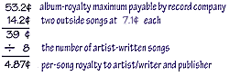

As you can see, the writer/artist's mechanical royalty has been reduced to 4.87¢ per song from 5.32¢ per song due to the inclusion of two outside-written songs on the album. By the same token, as the writer/artist records more outside-written songs, the artist's per-song royalties for his/her own works will be further reduced. Sometimes, in fact, when a writer/artist has recorded a substantial number of songs by other writers, he/she has been put in a position of receiving no royalties for his/her own songs, since the aggregate album-royalty maximum has been paid out to outside songwriters and publishers. Ouch! But it can get even worse. There have actually been instances in which the writer/artist's mechanical royalties have been in the minus column for every album sold because of the operation of these controlled-composition clauses. Additionally, the era of multiple remixes has given rise to a clause which provides that the writer/artist will only receive a mechanical royalty for one use of his/her song regardless of the number of versions contained on the single or album.

Television
When a producer wants to use an existing song in a weekly TV series, special, miniseries, or made-for-TV movie, permission must, with few exceptions, be secured from the song's publisher. In this regard, the producer of the show will decide on how the song is to be used (for example, background vocal or instrumental, sung by a character on camera, over the opening or ending credits) and the medium over which the program will be broadcast (free TV, basic or premium cable, pay-per-view). The producer or his/her music-clearance representative will then contact the publisher of the composition, describe how the song will be used, ask for a specified period of time to use the song in the program (usually from three years to life of copyright), define the territory in which the program may be broadcast (usually the world but sometimes limited to only specified countries), negotiate a fee, and then sign what is known as a synchronization license. This is how the standard "Love and Marriage" came to be used as the theme for Married . . . With Children, and how Billy Joel's "You May Be Right" wound up as the opening theme to Dave's World.

Since home video has become an important ancillary market for TV programming, negotiations (often on an option basis) will take place for home use as well. Considering that some television programs (normally miniseries and made-for-TV movies) are also released in movie theaters in countries outside the U.S. (more on that later), the producer may also request such rights and negotiate additional fees for such non-television uses. And since many TV shows are eventually broadcast over media other than that on which they were initially aired (for example, a pay-TV program being broadcast on free over-the-air stations), a producer may also request prices for a wide range of additional options. Synchronization fees are negotiated and typically range from $1,200 to more than $1,800 for a five-year worldwide free television license and from $4,000 to more than $9,000 for life-of-copyright licenses.

Motion Pictures
When a movie producer wants to use an existing song in a theatrically released film -- like "What the World Needs Now" and "Hound Dog" in Forrest Gump, or "Groovin" and "Blue Moon" in Apollo 13 -- the producer must negotiate with the music publisher for use of the composition. Once an agreement is reached, the producer will sign a synchronization license which will give it the right to distribute the film to movie theaters, sell it to television, and use the song in "in context" TV promos and theatrical previews.

The amount of the motion-picture synchronization fee depends upon a number of factors: how the song is used (sung by a character in the film, background instrumental, vocal performance of a recording from a jukebox, etc.), the overall budget for the film and the music budget, the stature of song being used (standards like the examples above, current hits, new compositions), the actual timing of the song as used in the film (45 seconds, one minute, two minutes), whether there are multiple uses of the song in various scenes, whether the use is over the opening or closing credits, whether there's a lyric change, the term of the license (normally life-of-copyright), the territory of the license (usually the world or the universe), and whether there is a guarantee that the song will be used on a soundtrack album or released as a single. So there are lots of variables.

The synch fees (which include home-video rights) charged by music publishers are usually between $12,000 and $40,000, with the majority between $15,000 and $35,000. On occasion, a music publisher will reduce the synchronization fee for a song if the producer guarantees that there is a soundtrack-album commitment from a major label and that the song being licensed for the film will be on the album. Considering the phenomenal success of some movie soundtracks -- and the royalties that are generated -- such a reduction in the synch fee may substantially benefit the publisher and songwriter in the long run, but each situation must be decided on its own merits.

In most countries outside the United States, motion picture theaters are required to pay performance royalties for music used in theatrically distributed films. These fees are collected by the local performing-rights society in each country (PRS in England, GEMA in Germany, JASRAC in Japan, SACEM in France, SOCAN in Canada, APRA in Australia, etc.) which, in turn, distribute royalties to the writers and publishers of music contained in the films distributed in their territories. The foreign societies will remit the writer's share of such monies directly to the writer's performing rights society, which will then pay these theatrical-performance royalties as a foreign distribution. In simple language, what this means is that, if you managed to get a song in a movie that becomes a hit overseas, you'll get checks from your domestic performing rights society that they in turn have received from the foreign performing-rights organizations that collected the money for you in the first place.

In contrast to the handling of writer royalties, the music publisher normally allows its representative in each foreign territory to directly collect its share in the local country.

Theater license fees vary by country and are usually either a percentage of the theater's box office receipts or a fee based on the number of seats or the number of screenings per week. Because of the worldwide appeal of many motion pictures -- the Batman and Terminator series, to cite a couple of obvious examples -- it's not unusual for successful films to generate between $50,000 and $200,000 in total theater performance royalties.

Home Video
Since the VCR market has become enormous throughout the world, the sale of videos represents a significant source of revenue for the music publisher and songwriter. Home-video licensing is normally handled in one of three ways: (1) In the per-video royalty approach, the royalty paid is based on a set rate (usually from 8¢ to 15¢ per song) for each video sold. For example, if 100,000 cassettes are sold and a particular song has a 10¢ royalty, the payment will be $10,000. (2) Most video distributors demand that publishers accept a one-time buy-out fee for all video rights, regardless of how many videos might be sold (a fact of life in today's movie and TV-series episode market which must be faced and negotiated accordingly). (3) Under the roll-over advance formula, the producer or video distributor pays a certain advance for a specified number of videos, with additional predetermined sums paid as certain sales plateaus are achieved (for example, $8,000 for the first 100,000 units and an additional $8,000 for each additional 100,000 units sold).

Commercials
An extremely valuable source of income for the songwriter and music publisher is the use of songs in radio and TV commercials for consumer products. Microsoft paid a pretty penny to use the Rolling Stones' "Start Me Up" in its Windows 95 campaign, and "When You Wish Upon a Star" (from the 1940 Disney animated feature Pinocchio) has been the musical hook of TV spots for Disneyland and Disney World for years. The fees paid by advertising agencies and their clients for commercials can be substantial (from $75,000 to more than $500,000 per year for successful songs), depending on whether (a) the commercial is for radio or TV, (b) it's targeted for a national or limited-territory campaign, (c) there are options for other countries, (d) the original lyrics are being changed or new lyrics added, or (e) the ad agency requests the song for all-advertising exclusivity or product-category-only exclusivity (we'll explain that further in a minute).

On occasion, an agency will ask for a non-broadcast test period during which it will test the commercial in shopping malls, inter-agency screenings, etc., to determine whether the pairing of the song and the product is effective. Fees for this off-air testing range from $1,000 to more than $10,000, and the term normally ranges from a week to a few months. In other instances, the ad agency will request a limited-broadcast test period -- during which a commercial will actually be aired -- for a specified regional market (for example, television in New York or California for two months only, or a three-month test in cities that contain not more than 10% of the total U.S. population). Fees for regional-broadcast test periods normally range from $5,000 to more than $20,000, depending on the duration of the test period, the population of the region, the importance of the song, the product being advertised, and whether there has been a lyric change.

Certain major advertisers may request total exclusivity (a restriction for licensing to all products as opposed to just similar or competing products) from a publisher, but the fees for this type of grant are substantial for a recent hit song or well-known standard (from $175,000 to more than $500,000), since the song is effectively being taken out of the marketplace. However, most commercial licensing agreements provide for restrictions on licensing only competing, incompatible, or similar products. For example, a beer commercial may restrict the writer or publisher from licensing the same song for another alcoholic beverage commercial but will allow licensing for use in a food, electronics, or automobile advertising campaign.

Broadway Musicals
One of the most lucrative markets for a song can be its use in a Broadway show, since, if the play is a hit, the income from live theatrical performances, soundtrack albums, singles, film rights, touring productions, home video, sheet music, and stock and amateur production rights can mean hundreds of thousands of dollars to the songwriter and publisher. Perennials like "A Chorus Line," "West Side Story," and "Phantom of the Opera" have generated huge revenues over the years. On the other hand, considering that the vast majority of musicals presented on Broadway lose most if not all of the money invested and that getting a song into a Broadway play is extremely difficult, this is an area with which most songwriters and publishers, unless they're involved with songs actually created for the play, will have little or no contact.

Combined music and lyric royalties for the Broadway run and first-class national touring productions usually range between a 3% pre-recoupment of costs royalty and a 4% post-recoupment pro-rated share of the box-office receipts if a percentage royalty is negotiated (which can mean from $200,000 to more than $10 million per year for all songs in a hit show) or a fixed dollar amount per week (from $250 to $1,000, regardless of the success of the play) if a non-percentage royalty is agreed to.

Recording Artists Royalties
This overview is primarily concerned with some of the major sources of songwriter/publisher earnings, but since many songwriters are also recording artists, a brief mention should be made of the contractual factors that affect income in the recording arena. Artist royalties usually range from 10% to 25% of the suggested retail price for top-line albums, with deductions being made for packaging costs. For example, if a songwriter/artist has an 18% royalty, a 25% packaging deduction, and sells 3 million CDs in the U.S. of a $17 suggested-retail-priced album, the basic calculations would look like this:

Recording-artist royalties represent an extremely complex area, and the above illustration is included only to present the basic principles involved. But you should know that there are a bunch of additional issues -- including, but not limited to, free goods; reserve accounts; return privileges; midline, budget-line, record-club, and foreign reductions; 90% sale provisions; new-technology rate reductions (which affect CD royalties); cut-out and surplus-copy provisions; video, tour support, and promotion expenses; recording costs; advances; and controlled composition clauses -- which further affect the monies a songwriter/recording artist receives.

Foreign Country Royalties
Another source of income for most U.S. writers are performance, mechanical and artist royalties generated in foreign countries. Effective and knowledgeable representation (whether it's your performing-rights society, publisher or other representative) is a necessity for proper collection in this area.

Conclusion
The world of songwriting and music publishing may be complex, but it's far from mysterious. Just as every other business has its particular rules, special ways of conducting business, idiosyncrasies, and unique revenue-producing areas, so too does songwriting/publishing. This erstwhile business of pennies, piano rolls, and sheet music has been transformed by the technology of the communications industry into a multibillion-dollar worldwide industry and one of the centerpieces of entertainment programming. It's a difficult field to succeed in and a difficult field to remain successful in. But even though the music business is based on creativity, it's still a business, and knowledge of its inner workings is one of the keys to a lasting, productive, and financially rewarding career.

Single Song Royalties Example
Excerpt from Los Angeles Times Pop Music Section, December 13, 1998:

"Dianne Warren may not be recognized when she pulls up at intersections, but the San Fernando Valley native is paid handsomely for her anonymity. Being the songwriter of a worldwide hit can easily mean $1 million in record royalties and performance fees. A blockbuster could double or triple that sum--and Warren has had lots of blockbusters, including "Un-Break My Heart," one of the most stylish pop tunes in years. Consider: Every time someone buys a copy of Braxton's 1996 recording of the song, Warren receives 7.1 cents, the songwriting royalty set by U.S. copyright statutes. Each time you hear the song on the radio or on television or in a club or at a football game, she's also adding to her income. In the case of "Un-Break My Heart," she has earned nearly $1.2 million in the U.S. alone for the first 18 months of the song's life. Broken down, that's an estimated $504,000 in recording royalties (based on 4.8 million album sales and 2.3 million singles sales) and $695,000 in radio, TV and live performance fees. With foreign sales and airplay, that total could easily reach $2.5 million to $3 million. If Warren decides to follow in the footsteps of the Rolling Stones ('Start Me Up') or Bob Seger ('Like a Rock') and sell one of her songs for a TV commercial (something she is cautiously exploring), she could collect another $150,000 to $500,000 in fees and residuals, according to industry estimates. All those figures add up--rapidly, once you've got a body of work like Warren's. That's why publishing is a $6-billion-a-year business worldwide, according to the National Music publishers Assn. "

Advertising Royalties Formula
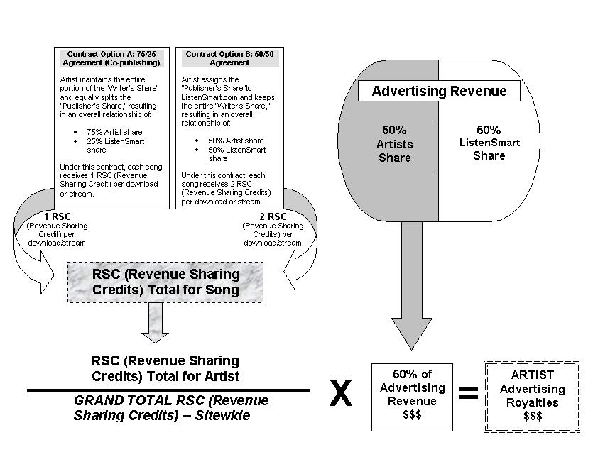
Figure 16: Advertising Royalties Formula

Reversion Clause Flowchart
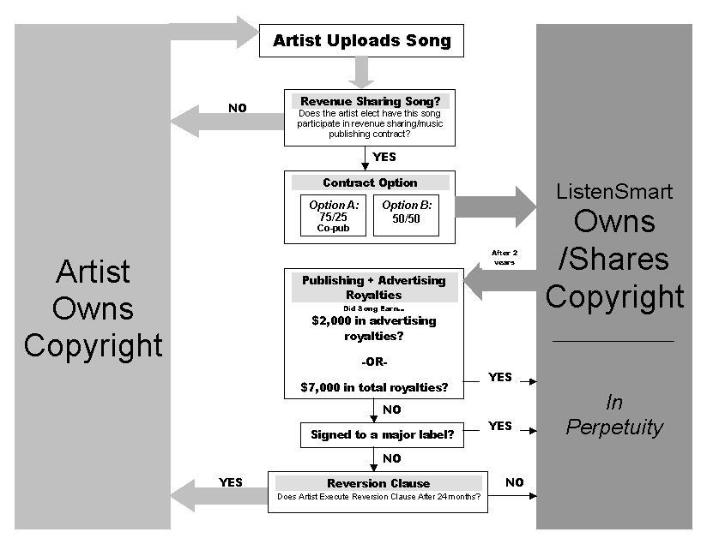
Figure 17: Reversion Clause Flowchart

Artist Meta-Data Collected by ListenSmart
Contact Info
· Artist or band name
· Email address
· Mailing address
· FEDERAL TAX ID OR SSN#

BAND/ARTIST BRIEF DESCRIPTION

BAND/ARTIST FULL DESCRIPTION

BAND/ARTIST HISTORY

BAND/ARTIST STYLE DESCRIPTION

PRESS REVIEWS

“GOOD THINGS PEOPLE SAY ABOUT OUR MUSIC”

MUSICAL INFLUENCES

ROSTER INFORMATION

GOALS AND OBJECTIVES
· 0 1 2 3 4 5 Recording Contract
· 0 1 2 3 4 5 Radio Airplay
· 0 1 2 3 4 5 Live Local Gigs/Concerts
· 0 1 2 3 4 5 Concert Tours
· 0 1 2 3 4 5 Distrubution Promotion of existing CD(s)
· 0 1 2 3 4 5 Song Plugging(encouraging other major artists to record your songs)
· 0 1 2 3 4 5 Association with Producer
· 0 1 2 3 4 5 Association with manager
· 0 1 2 3 4 5 Association with Music Attorney
· 0 1 2 3 4 5 Synchronization Contracts(for movies,TV,computer games, etc.)
· 0 1 2 3 4 5 Professional Critique
· 0 1 2 3 4 5 Press Kit & Promotion
· 0 1 2 3 4 5 Other

Famous Artist Sound Associations

GIG/TOUR HISTORY
· # of live performances in past 12 months
· Average attendance

GIG/TOUR Availability (over the next 2 years)
· No live performances
· Local Only
· Regional Only
· National Only
· International

DISCOGRAPHY
· Label
· Distribution
· Units Sold
· Airplay

Business Relationships
· Attorney
· Manager
· Agent
· Label
· Publisher
· Performing Rights Affiliation
· Age
· Other contacts w/in the music industry

Significant Achievements

Additional Comments

Song Meta-Data Collected by ListenSmart
Song Name

Brief Song Description/Full Song Description

Composer(s)/Composition Date

Song Lyrics (+ Languages & Translations) & Vocal Style (Male, Female, Chorus, Acapella, etc.)

Similar (Famous) Songs

Instruments

Song Tempo
- Very Fast
- Fast
- Medium
- Slow
- Very Slow
- Shifting Tempos
- Floating Tempos
- Undefined Tempos

Song Mood (Up to 5 moods may be selected per song)

Aggressive
Angry
Anxious
Bad
Calm
Careful
Caring
Cautious
Chaotic
Confident
Prof. Critique
Cool
Curious
Dancing
Dark
Determined
Disillusioned
Doubtful
Dramatic
Easy
Ecstatic
Envious
Erotic
Fearful
Flirtatious
Forceful
Friendly
Funny
Good
Groovy
Happy
Hard
Hectic
Inquisitive
Light
Intense
Longing
Melancholic
Mellow
Mournful
Mysterious
Nervous
Patriotic
Pleading
Pensive
Pompous
Pushy
Relaxed
Right
Sad
Serene
Sexy
Silly
Sincere
Smoky
Snobbish
Soft
Sorry
Strange
Strong
Stubborn
Suggestive
Thankful
Thoughtful
Unfriendly
Uplifting
Worried
Wrong

Song Subject Matter (Up to 5 subjects may be selected per song)

Action
Achievement
Age
Animals
Astrology
Autumn
Baby
Beach
Beauty
Beer
Betrayal
Birds
Birthday
Body
Boys
Business
Cars
Cheating
Children
Christmas
Closed
Clothes
Colors
Comedy
Country
Cry
Dark
Days
Death
Desert
Desire
Devotion
Distance
Divorce
Dreams
Drugs
Easter
Emotions
Eyes
Family
Fashion
Fight
Flowers
Food/Drink
Forest
Forgiveness
Freedom
Friendship
Fun
Future
Gambling
Girls
Goodbye/Leaving
Gun(s)
Halloween
Heart
Heartache
Heaven
Hello/Greeting
Help
High
History
Holiday (misc.)
Home
House
Ice
Joy
Leaving
Life/Death
Light
Liquor
Loneliness
Lonely
Losing
Indepen. Day
Love
Low
Luck
Magic
Marriage
Meditation
Memories
Men
Money
Morning/Night
Mountains
Names
Nature
New
No Selection
Nostalgia
Ocean
Old
Open
Pain
Party
People
Places
Pleasure
Reality
Relationships
Religion
Right
River
Romance
School
Searching
Sex
School
Sky
Smile
Smoking
Space
Spirit/Ghost
Sports
Spring
Star
Stars
Stop
Street
Summer
Sun-Moon-Sky
Suspense
Tears
The 20's
The 30's
The 40's
The 50's
The 60's
The 70's
The 80's
The 90's
Thanksgiving
Time
Travel
Victory
Walk
Water
Weather
Wind
Wine
Winning
Winter
Women
Work
Wrong
Young

MP3.com Monthly Key Metrics, http://www.mp3.com/investor/keymetrics.html
National Association of Music Merchandisers (NAMM), 1998
National Music Publishers Association’s “Ninth Annual International Survey of Music Publishing Revenues,” 1997, http://www.nmpa.org/nmpa/survey9/base.html
National Music Publishers Association’s “Ninth Annual International Survey of Music Publishing Revenues,” 1997, http://www.nmpa.org/nmpa/survey9/base.html
Soundscan Inc., Contact info: http://www.latsi.com/lats/what/whatcol/text/soundscan.htm
National Music Publishers Association’s “Ninth Annual International Survey of Music Publishing Revenues,” 1997, http://www.nmpa.org/nmpa/survey9/base.html
National Music Publishers Association’s “Ninth Annual International Survey of Music Publishing Revenues,” 1997, http://www.nmpa.org/nmpa/survey9/base.html
MP3.com Monthly Key Metrics, http://www.mp3.com/investor/keymetrics.html

